**Bedford Hospital Learning Disability Awareness Staff Guidance and Workbook**

The Learning Disability Liaison Team of Nurses offer a range of training across both hospital sites, but there are times when they might not be able to.

With this in mind, we have put together this learning disability workbook and supporting guidance so that we can continue to educate staff about how best to support people with a learning disability when on the wards or being seen in various departments.

It does not matter what area of the hospital you work in; it is likely that you will encounter someone who has a learning disability. For some of you this may be new and you may feel that you do not know how to support people. You might be fearful of working with someone with a learning disability because you do not know how to communicate with them.

By reading this guidance and information, we hope that you will feel better placed to help meet people’s needs. You can always contact us as well for additional information and support; we are based in both Bedford Hospital and the Luton and Dunstable Hospital. Our contact details are the end of this booklet and we are always happy to help.

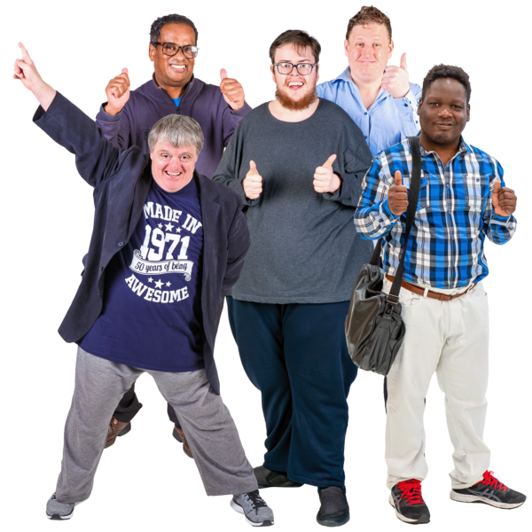

Compiled by Simone Mingay (Updated 22.06.2023)

**What is a learning disability?**

Before we start, how many of you know what a learning disability is? Have you cared for someone who has a learning disability before? Can you think of someone you know that has a learning disability?

|  |
| --- |
| **List some of the things that you consider to be a learning disability** |
|  |

**How do you define a learning disability?**

A learning disability is defined by the **Department of Health and Social Care (DHSC) (2001)** as:

“a significantly reduced ability to understand new or complex information, to learn new skills (impaired intelligence), with a reduced ability to cope independently (impaired social functioning), which started before adulthood.**”**

A learning disability is different for everyone. The degree of disability can vary greatly, being classified as mild, moderate, severe or profound. In all cases, a learning disability is a lifelong condition and cannot be cured.

A learning disability, not to be confused with a learning difficulty, is a label given to a group of conditions that are present before the age of 18. This will affect the way individuals develop in all core areas, and ultimately how they live their lives and access health care.

**Learning Difficulty- not to be confused with a learning disability?**

A learning difficulty, is a reduced intellectual ability for a specific form of learning and includes conditions such as:

Dyslexia (difficulty with reading and writing),

Dyspraxia (affecting physical co-ordination and motor difficulties)

Attention Deficit Disorder (ADD/ADHD) – concentration difficulties with heightened activity levels and impulsiveness

**A learning disability is not:**

* Acquired Brain Injury – occurs after the age of 18 years
* Dementia
* Mental Health Disorder
* CVA
* Autism Spectrum Disorder

A learning disability is caused by something which affects the development of the brain either before birth, during birth or in early childhood.

Possible causes may include:

* an inherited condition – for example, Fragile X syndrome
* abnormal chromosomes – for example, Down’s syndrome or Turner syndrome
* exposure to environmental toxins or infections and illness during pregnancy
* a very premature birth
* complications during birth, resulting in a lack of oxygen to the baby’s brain
* illness – for example, meningitis or measles; or injury or trauma to the brain in early childhood

Sometimes the cause of a learning disability remains unknown.

The causes of a learning disability mainly fall into 3 distinct areas, developed in the: Prenatal, Perinatal and Postnatal period

|  |  |  |
| --- | --- | --- |
| Prenatal | Perinatal | Postnatal |
| **Chromosome and genetic anomalies**  For example:  Down’s syndrome  Williams syndrome  Rhett syndrome  **Maternal infections:**  Rubella  **Environmental Issues:**  Foetal alcohol syndrome (can also impact postnatal) | **Precipitated or prolonged** **labour:**  Cerebral palsy  **Prematurity, Environmental, i.e. abuse, neglect:**  Global developmental delay | **Infection:**  Meningitis  Measles  Encephalitis  **Injury:**  Abuse  Accident Trauma  **Chromosome and genetic anomalies:**  Batten disease  Tay-Sachs disease |

**Classifying a learning disability**

|  |  |
| --- | --- |
| Intellectual Disabilities | Code Description |
| F70- IQ level 50-55 to approximately 70 | **Mild learning disability**  Person might live independently or with minimal support; they may not see themselves as having a learning disability but might find themselves in vulnerable situations. |
| F71- IQ level 35-40 to 50-55 | **Moderate learning disability**  More likely to require planned support with all aspects of daily living and have difficulty in communicating with others and participating in complex decisions. |
| F72- IQ level 20-25 to 35-40 | **Severe learning disability**  Will require full support and supervision with daily living. More likely to have significant communication issues and other co-morbid conditions. |
| F73- IQ level below 20-25 | **Profound learning disability**  Person will be fully dependent on others for all aspects of daily living; requiring 24-hour care. They are more likely to have additional complex health needs and extremely limited communication skills. |

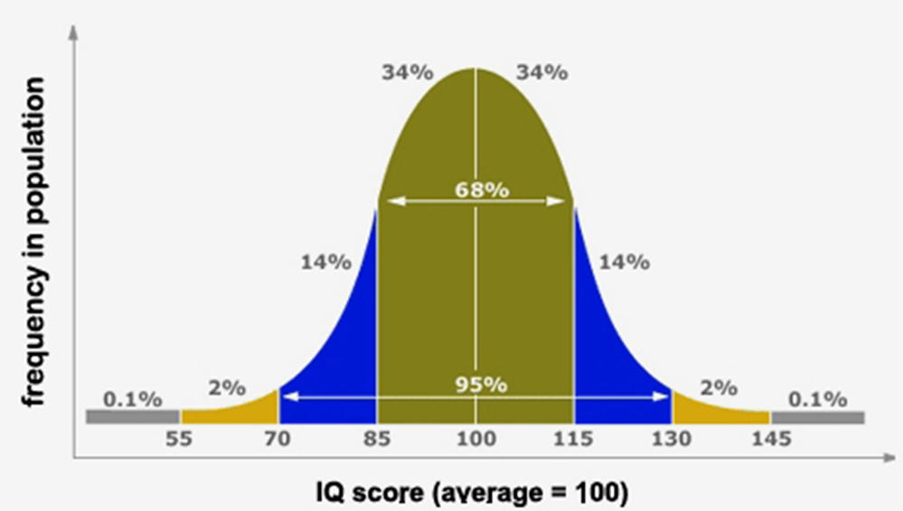

**So, now that you have a little more information; have a think about how you might know that someone has a learning disability. Make a list below:**

|  |
| --- |
|  |

When it comes to you supporting people on the wards or in outpatient areas, these are some of the possible indicators, which might help you to know if someone has a learning disability:

* The more severe or profound the LD it can be easier to identify
* They may come in with a paid carer or a family carer
* One indicator may be in the way that they communicate and/or the amount of support that they require to carry out daily tasks
* They may have a communication passport to guide staff as to their communication preferences and appropriate method of communication.
* If the person has a hospital passport or All about Me document this may indicate they have a learning disability.
* There may be a Flag or Alert on electronic records systems
* Contact from the Adult Learning Disability Team within the local council.
* Care plans and risk assessments from the care provider may give an indication that a person has more complex needs.

Indicators that the patient may not have LD

* The gained qualifications like GCSE or O levels
* They successfully attended mainstream education without support
* Normal development up until 18
* Recorded IQ above 70
* No problems with abstract concepts like time

**However, if you or your colleagues are ever in doubt; then please contact the Learning Disability Liaison Team. We are always happy to offer advice and support or further training as required.**

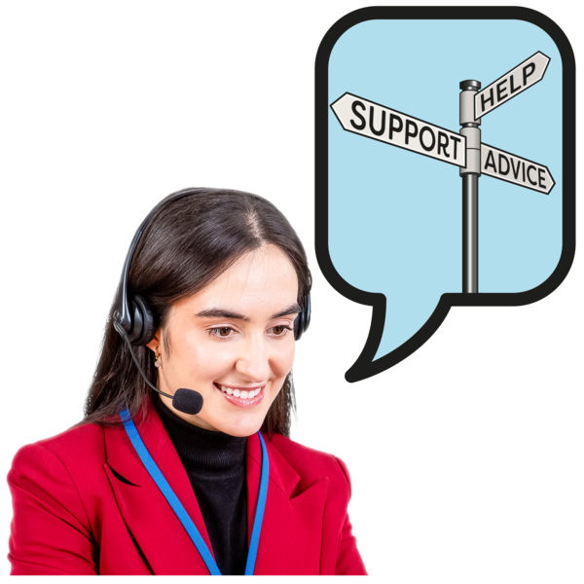

Core Learning Disability Publications

There have been many core documents published in respect of people with a learning disability; some of these have arisen because of the way in which people with a learning disability have been treated in health and social care settings.

**Valuing People 2001** <https://assets.publishing.service.gov.uk/government/uploads/system/uploads/attachment_data/file/250877/5086.pdf>

**Valuing People Now 2009** <https://assets.publishing.service.gov.uk/government/uploads/system/uploads/attachment_data/file/215891/dh_122387.pdf>

[Six Lives: progress report on healthcare for people with learning disabilities](https://eur03.safelinks.protection.outlook.com/?url=https%3A%2F%2Fwww.gov.uk%2Fgovernment%2Fpublications%2Fsix-lives-department-of-health-second-progress-report&data=05%7C01%7Cmelissa.graham%40dhsc.gov.uk%7C736b2f8b80da40126a1f08db2a29b979%7C61278c3091a84c318c1fef4de8973a1c%7C1%7C0%7C638150131075874110%7CUnknown%7CTWFpbGZsb3d8eyJWIjoiMC4wLjAwMDAiLCJQIjoiV2luMzIiLCJBTiI6Ik1haWwiLCJXVCI6Mn0%3D%7C3000%7C%7C%7C&sdata=85i6KR%2Fiyy5TpO3epx1ZG2%2F%2FOwRmPW3%2Bdk2Atz3PE0Q%3D&reserved=0) demonstrates that more people with learning disabilities have taken up the opportunity of an annual health check to improve their health and enable preventive interventions to stop potential health crises.

Mencap’s [Death by Indifference](https://www.mencap.org.uk/get-involved/campaign-mencap/our-campaign-reports) report and follow-up report [Death by Indifference: 74 and Counting](https://www.mencap.org.uk/get-involved/campaign-mencap/our-campaign-reports) identify continued institutional discrimination in the NHS and calls for systematic monitoring by the Department of Health and Social Care to ensure that the health needs of people with a learning disability are being met.

[LeDeR - learning from lives and deaths](https://leder.nhs.uk/) is a national service improvement programme funded by the NHS which aims address the health inequalities experienced by people with a learning disability and reduce premature mortality.

[A Fair, Supportive Society: Summary Report](https://www.instituteofhealthequity.org/resources-reports/a-fair-supportive-society-summary-report#:~:text=Summary%20The%20IHE%20report%20A%20Fair%2C%20Supportive%20Society,NHS%20England%20highlights%20key%20facts%2C%20statsistics%2C%20and%20interventions.) from the Institute of Health Equity outlines a social determinants of health approach to improving the lives and health of people with a learning disability.

Learning Disability Applying all our health <https://www.gov.uk/government/publications/learning-disability-applying-all-our-health/learning-disabilities-applying-all-our-health>

If you are able to, please look at some of the documents. All of these key reports have helped to change the way that people with a learning disability are supported; and have led to key changes in some of the things we do.

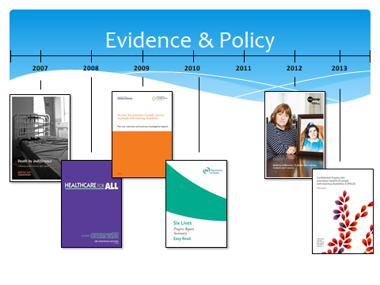For example in the community, the government is committed to reducing the incidents of co-morbidities and premature deaths for people with learning disabilities. Our community team helps to try to ensure that as many people as possible with a learning disability have an annual health check by their GP.

**Learning Disability Statistics**

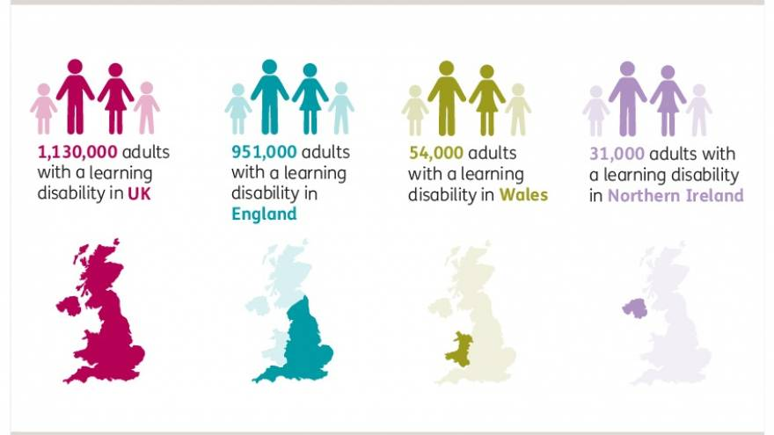

|  |
| --- |
| **Adults of working age with a learning disability (18-64)**   * + 870,000 adults of working age with a learning disability in the UK   + 732,000 adults of working age with a learning disability in England   + 40,000 adults of working age with a learning disability in Wales   + 25,000 adults of working age with a learning disability in Northern Ireland**.** |

**Approximately 2.16% of adults in the UK are believed to have a learning disability.**

In total, the number of adults with learning disabilities getting some form of long-term social care increased from 139,555 people in the period 2014 to 2015 to 147,915 people in 2017 to 2018.

On average, the life expectancy of women with a learning disability is 18 years shorter than for women in the general population.

The life expectancy of men with a learning disability is 14 years shorter than for men in the general population (NHS Digital 2017).

Poor quality healthcare causes health inequalities and avoidable deaths

The 2018 Learning Disabilities Mortality Review (LeDeR) found the median age at death was 60 for men and 59 for women, for those (aged 4 and over) who died April 2017 to December 2018. This is significantly less than the median age of death of 83 for men and 86 for women in the general population. This means the difference in median age of death between people with a learning disability (aged 4 and over) and the general population is 23 years for men and 27 years for women.

LeDeR also reported the median age of death for different levels of impairment:

* 62 for people with a mild learning disability
* 63 for people with a moderate learning disability
* 57 for people with a severe learning disability
* 40 for people with profound and multiple learning disabilities.

(University of Bristol Norah Fry Centre for Disability Studies, 2019)

**People with a learning disability often have common health problems that include:**

|  |  |
| --- | --- |
| **Respiratory disease: this is the most common cause of death; the rates are 3 times higher than the general population at 46-52%.**  **As many as a quarter of respiratory deaths are directly linked to aspiration pneumonia.** | **Coronary Heart Disease: this is the 2nd most common cause of death in people with a learning disability; nearly 50% of people with Down’s Syndrome have congenital heart defects.** |
| **Gastro- oesophageal reflux disease (GORD): 48% of people with a learning disability with an IQ below 50 experience this. Predisposing factors include cerebral palsy, scoliosis, severe and profound learning disabilities and the prescription of anti convulsants.** | **Osteoporosis- substantially less bone density.** |
| **Epilepsy: 22% of people with a learning disability have epilepsy; this is more than 20 times more common than in the general population.** | **Swallowing problems: Dysphagia; if this is not managed it can lead to respiratory tract infections. 60% of people with Cerebral Palsy have difficulties with chewing and/ or swallowing.** |
| **Thyroid Function: greater risk of hypothyroidism** | **Dementia: 4 times a greater risk and early onset in people with Down’s Syndrome** |
| **Cancer: The pattern of cancer is different in people with a learning disability with them having lower rates of lung, prostate and urinary tract cancers but higher rates of oesophageal, stomach, gall bladder and leukaemia.**  **In the general population 77% of women have cervical smear tests; for women with a learning disability; the percentage is 19%** | **Helicobacter Pylori Infection: This is endemic in the learning disability population and it is widely believed that this is a contributory cause for the higher prevalence of gastric carcinoma.** |

People with a learning disability have more health needs than other people but are often much less able to get the help that they need. This is something that we can all help to change.

**The Equality Act 2010** is a legal requirement not to treat people with a disability less favourably. It gives a statutory requirement to make reasonable adjustments that are often about practices and procedures, rather than just physical access.

It also takes into account something called diagnostic overshadowing. This is where someone’s presenting symptoms are attributed to their learning disability, rather than seeking a potentially treatable cause.

Therefore, when someone presents with a new behaviour or existing ones escalate you should consider whether they might have:

|  |  |  |
| --- | --- | --- |
| Physical Problems | Psychiatric Causes | Social Causes |
| Pain or discomfort from infection,  toothache,  constipation,  Reflux. | Depression  Anxiety  Psychosis  Dementia | Change in carers  Change in care pattern or home circumstances  Abuse  Grief  Bereavement |

So, how can you help people with a learning disability?

1. We can make sure we communicate effectively with them.
2. Give them time and be patient.
3. Use simple language and key words.
4. Don’t overload people with too many words- often they will only be able to recall one or two words and they might not be the most important ones.
5. Give bite sized information.
6. Supplement with easy read information or social stories
7. Make sure they have understood by asking them to repeat back to you what you have told them.

Remember people often have sensory issues too; 40% are likely to have some hearing loss and 30% problems with their sight.

It is important to remember that communication problems can lead to behaviour that can be difficult to manage.

You might find that the use of visual images can help; either pictures or basic Makaton signs.

Maintain eye contact, facial expression and watch your body language as people can notice what you are thinking through observing your body language.

**Core documents to read when someone comes into hospital:**

* All about Me Document
* Hospital Passport

These contain vital information about how people like to be cared for and supported; their likes and dislikes. A well-completed one of these will be invaluable if someone does not have a family member or carer with them.

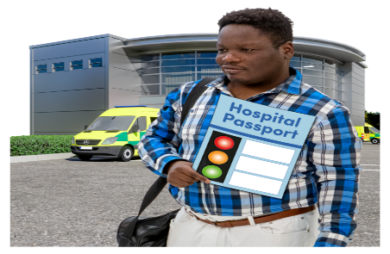Specific care and management plans which will offer you additional information about how to meet their needs in specific areas; for example epilepsy, diabetes, risk feeding.

**Learning from Deaths Mortality Review (LeDer)**

The Learning Disabilities Mortality Review (LeDeR) programme came into force in May 2015 to support local areas across England to review the deaths of people with a learning disability, to learn from those deaths and to put that learning into practice. All deaths for people with learning disability have to be notified and reviewed (4yrs upwards)

**LeDeR aims to**:

* Improve care for people with a learning disability and autistic people.
* Reduce health inequalities for people with a learning disability and autistic people.
* Prevent people with a learning disability and autistic people from early deaths.

A LeDeR review looks at key episodes of health and social care the person received that may have been relevant to their overall health outcomes. They look for areas that need improvement and areas of good practice. These examples of good practice are shared across the country. This helps reduce inequalities in care for people with a learning disability and autistic people. It reduces the number of people dying sooner than they should.

Some statistics for Medical conditions commonly recorded on part 1 Death Certificate idenmtified as part of LeDer reviews:

* Pneumonia 25%
* Aspiration Pneumonia 16%
* Sepsis 7%
* Ischemic heart disease 6%
* Epilepsy 5%

**It is important to know these facts so that you can work hard to try and prevent people from getting such conditions. By working together and having a better understanding of the key issues which affect people with a learning disability, you can play your part in this.**



**Mental Capacity and Consent**

The Mental Capacity Act 2005 is a law that protects vulnerable people over the age of 16 around decision-making. It says that:

Every adult, whatever their disability, has the right to make their own decisions wherever possible.

People should always support a person to make their own decisions if they can. This might mean giving them information in a format that they can understand (for example this might be easy read information for a person with a learning disability) or explaining something in a different way.

But if a decision is too big or complicated for a person to make, even with appropriate information and support, then people supporting them must make a ‘best interests’ decision for them.

**The five main principles of the Mental Capacity Act**

1. Always assume the person is able to make the decision until you have proof they are not.

2. Try everything possible to support the person make the decision themselves.

3. Do not assume the person does not have capacity to make a decision just because they make a decision that you think is unwise or wrong.

4. If you make a decision for someone who cannot make it themselves, the decision must always be in their best interests.

5. Any decisions, treatment or care for someone who lacks capacity must always follow the path that is the least restrictive of their basic rights and freedoms.

It's also important to remember that a person may have capacity for some decisions but not others, or they may not have capacity right now but may regain it in the future with support. This means all capacity decisions should be reviewed regularly to make sure they still reflect the person's ability to make decisions.

**Supporting someone to make a decision**

Before deciding that someone lacks the capacity to make a decision, all practical and appropriate steps must be taken to help him or her make the decision themselves.

**Making a best interest’s decision**

After all steps have been taken to support someone to make their own decision, if the person is assessed as lacking capacity to make that particular decision, then a ‘best interests’ decision must be made.

The person who makes the ‘best interests’ decision is called the ‘decision maker’. Who the decision maker is will depend on the situation and the type of decision.

**Five key principles**

The Act is underpinned by five key principles (Section 1, MCA). It is useful to consider the principles chronologically: principles 1 to 3 will support the process before or at the point of determining whether someone lacks capacity. Once you’ve decided that capacity is lacking, use principles 4 and 5 to support the decision-making process.

**Principle 1: A presumption of capacity**

Every adult has the right to make his or her own decisions and must be assumed to have capacity to do so unless it is proved otherwise. This means that you cannot assume that someone cannot make a decision for themselves just because they have a particular medical condition or disability.

**Principle 2: Individuals being supported to make their own decisions**

A person must be given all practicable help before anyone treats them as not being able to make their own decisions. This means you should make every effort to encourage and support people to make the decision for themselves. If lack of capacity is established, it is still important that you involve the person as far as possible in making decisions.

**Principle 3: Unwise decisions**

People have the right not to be treated as lacking capacity merely because they make a decision that others deem ‘unwise’. Everyone has their own values, beliefs and preferences which may not be the same as those of other people.

**Principle 4: Best interests**

Anything done for or on behalf of a person who lacks mental capacity must be done in their best interests.

**Principle 5: Less restrictive option**

Someone making a decision or acting on behalf of a person who lacks capacity must consider whether it is possible to decide or act in a way that would interfere less with the person’s rights and freedoms of action, or whether there is a need to decide or act at all. Any intervention should be weighed up in the particular circumstances of the case.

**Best interests’ checklist**

The Mental Capacity Act sets out a best interest’s checklist, which must be followed when making a best interests decision:

1. Will the person regain capacity?

2. Involve the person.

3. Consult all relevant people.

4. Consider all the information.

5. Do not make any assumptions.

6. Consider past, present and future wishes.

7. Always pick the very least restrictive option.

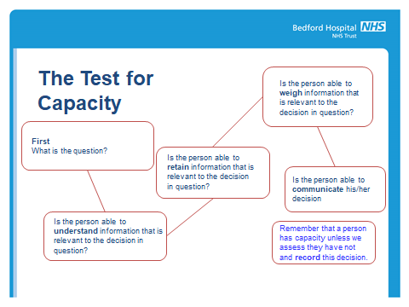

**Dementia:**

People with a learning disability:

* Are at greater risk of developing dementia at a younger age - particularly those with Down's syndrome
* Often show different symptoms in the early stages of dementia are more likely to have other physical health conditions that are not always well managed
* Are less likely to receive a correct or early diagnosis of dementia and may not be able to understand the diagnosis
* May experience a more rapid progression of dementia, although this can be complicated by difficulty or delay in diagnosis
* May have already learned different ways to communicate (e.g. more non-verbal communication if their disability affects speech)
* People with learning disabilities are at increased risk of developing dementia as they age, compared with others without a learning disability, although the figures vary according to how the diagnosis is made.

About 1 in 5 people with a learning disability who are over the age of 65 will develop dementia. People with learning disabilities who develop dementia generally do so at a younger age. This is particularly the case for people with Down's syndrome: a third of people with Down's syndrome develop dementia in their 50s.

**Down's syndrome and dementia**

When people with Down's syndrome develop dementia, it is usually due to Alzheimer's disease.

Studies have estimated that 1 in 50 people with Down's syndrome develop dementia in their 30s, rising sharply to more than half of those who live to 60 or over. By comparison, the number of people among the population without learning disability aged 60-69 years who develop dementia is about 1 in 75. These studies, therefore, show a greatly increased risk of developing dementia among people with Down's syndrome, compared with the general population without a learning disability.

Studies have also shown that by the age of about 40, almost all people with Down's syndrome develop changes in the brain associated with Alzheimer's disease. However, not all go on to develop clinical symptoms of dementia. The reason for this increased risk has not been fully identified, however it is thought to be linked to the extra copy of chromosome 21 which most people with Down's syndrome have. This chromosome carries the amyloid gene thought to play a role in Alzheimer's disease.

**Other learning disabilities and dementia**

Studies suggest that approximately 1 in 10 people aged 50 to 65 with learning disabilities other than Down's syndrome have dementia. This rises to more than half of those aged 85 or over. This suggests the risk is less than for people with Down's syndrome but still between two and three times greater than for the general population.

At present we do not know why this is the case, and more research is needed. Genetic factors may be involved, or a particular type of brain damage associated with a learning disability could be a cause.

**Down's syndrome**

The symptoms of dementia in people with Down's syndrome are broadly similar to those seen in the general population, although there are some differences. Changes in behaviour and personality (eg becoming more stubborn, irritable or withdrawn) or loss of daily living abilities are common. Memory loss, the most common early symptom of Alzheimer's disease among older people generally, is seen less often as an early symptom in people with Down's syndrome. This may be because most people with Down's syndrome will already have poor short-term memory.

People with Down's syndrome are more prone to epilepsy (fits) than others. However, if a person with Down's syndrome starts to develop epilepsy later in life, it is usually a sign of dementia and should be investigated thoroughly. Up to three-quarters of people with Down's syndrome and dementia develop fits. More severe seizures are linked to a more rapid decline in health.

The middle and later stages of dementia in people with Down's syndrome are similar to these stages in the general population. However, there is some evidence that dementia in people with Down's syndrome progresses more rapidly. They may have earlier loss of basic skills such as walking, becoming incontinent and having swallowing difficulties.

**What are reasonable adjustments?**

Reasonable adjustments are the modifications that should be made by services, in terms of their approach or provision, to ensure that people can access the service in the same way as the general population.

* There is a legal obligation in the UK under the equality act (2010)
* A lack of reasonable adjustments makes people more vulnerable to poor health/ premature death
* Literacy (reduced access to and equity of health information and education).
* Access (to both acute and primary sectors – affected by barriers)
* 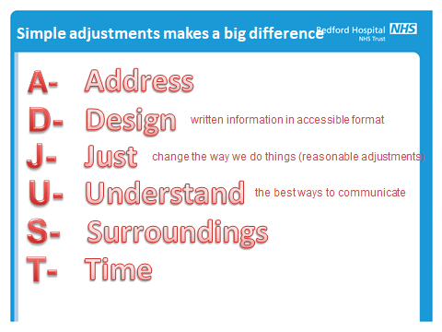Communication (lack of reasonable adjustment to make information accessible excludes some people with learning disability from decisions about their treatment or health).
* Get to know the level of the person understands (Key words/Symbolic understanding)
* Be careful with the vocabulary you use – jargon
* ‘Choose’ your words carefully; avoid confusing words or phrases, e.g.
* “Can you lend me a hand?”
* Watch the amount of information you give, and the speed at which you give it.
* Break sentences down – chunk information into key points
* Think about the grammar you use.
* Know and use appropriate objects, symbols and signs – what resources do you have?
* Also consider your tone of voice and always remember you are speaking to an adult

**Reasonable adjustments can also refer to other things that we do; for example–**

* **Supporting a person with a learning disability and autism to be cared for in a side room to reduce sensory overload.**
* **Enabling a carer to remain with a patient with learning disabilities so that they have a consistent routine and a familiar face with them.**
* **Offering a carer a recliner chair or bed when they stay and allowing more open ward access.**
* **Using pictorial images to enhance understanding when discussing important decisions.**

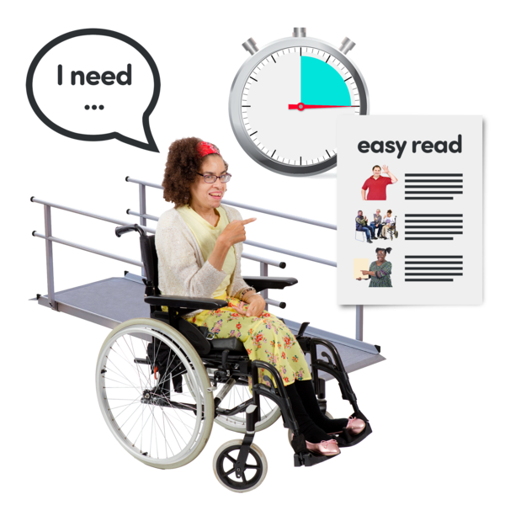

**The role of the Learning Disability Liaison Nurse in the acute setting**

**In both Bedford Hospital and the Luton and Dunstable Hospital, there is a small team of nurses who are based in the acute trust. We aim to help:**

Improve the experience of people who have a Learning Disability using the hospitals by raising staff awareness of their health needs and rights

Highlight and facilitate Quality Improvement of Acute Services for people with a learning disability

Develop and maintain partnership working between providers of Health and Social Care

**We try and visit the wards and departments on a daily basis to liaise with staff and speak with patients, family and carers and can support reasonable adjustments to be made and give advice and support to hospital staff.**

**If you need any advice or support then please contact us on:**

|  |  |
| --- | --- |
| **Bedford** | **Luton and Dunstable** |
| **Kara Greig, Lead Learning Disability Nurse 07768 132244**  **Rocialle Harding Learning Disability Liaison Nurse 07990 850866** | **Jeanette Broadhurst, Lead Learning Disability Nurse 07899 065737**  **Lucy Little, Learning Disability Liaison Nurse**  **07855 269102** |

**Therefore, it’s over to you now; we have given you some knowledge and information and we would you like you to test what you have learned and complete the following worksheet.**



**Learning Disability Workbook Assessment Questions**

|  |
| --- |
| **Please complete your name and department/ ward area in block capitals and sign and date:** |
| Your full name: |
| Your job title/ department: |
| I confirm that I have read and understood the Learning Disability Training Workbook: |
| Signed: |
| Dated: |

**Although there is no required pass mark, we would be grateful if you could complete the test so we can determine if the workbook and information has been effective for your needs and enhanced your understanding of how to support people with a learning disability.**

**Please circle your answers:**

1. **Making a change to the way we do things; to ensure that people with disabilities are not disadvantaged is called making a:**
2. **Minor amendment**
3. **Reasonable adjustment**
4. **Minor adjustment**
5. **Reasonable amendment**
6. **How likely is it that a person with learning disabilities has problems with their sight?**
7. **30%**
8. **40%**
9. **50%**
10. **90%**
11. **How likely is it that a person with learning disabilities has problems with their hearing?**
12. **30%**
13. **40%**
14. **50%**
15. **90%**
16. **Which of these describes what happens when someone’s health problem is wrongly attributed to his or her learning disability?**
17. **Diagnostic overshadowing**
18. **Differential diagnosis**
19. **Differential shadowing**
20. **Diagnostic shadowing**
21. **What is the key tool for use in hospital to aid the support someone with a learning disability is given?**
22. **Health care records and risk assessments**
23. **Hospital passport**
24. **All about Me document**
25. **All of the above**
26. **What is a learning disability?**
27. **A reduced ability to understand new or complex information.**
28. **A reduced ability to cope independently**
29. **A reduced ability to learn new skills**
30. **IQ above 70**
31. **Being unable to communicate verbally?**
32. **What are the common barriers for someone with a learning disability in accessing healthcare?**
33. **Communication**
34. **Fear and anxiety**
35. **Environment**
36. **Lack of awareness of the Mental Capacity Act**
37. **All of the above**
38. **In the general population, 77% of women have cervical smear tests; for women with a learning disability; what is the percentage?**
39. **19%**
40. **73%**
41. **100%**
42. **10.3%**
43. **List some of the core documents and national drivers which have helped shape how we support people with a Learning Disability.**

|  |
| --- |
|  |

1. **Give some examples of reasonable adjustments that can be offered to people.**

|  |
| --- |
|  |

1. **What can some of the signs and symptoms of dementia be in someone with a learning disability?**

|  |
| --- |
|  |

1. **In your own words, state what the purpose of a LeDer review is?**

|  |
| --- |
|  |

**Please return your completed form to the relevant Learning Disability Liaison Nurses for your hospital site.**

|  |  |
| --- | --- |
| **Bedford** | **Luton and Dunstable** |
| **Kara Greig, Lead Learning Disability Nurse** [**kara.grieg@nhs.net**](mailto:kara.grieg@nhs.net)  **Rocialle Harding Learning Disability Liaison Nurse**  **rocialle.harding@nhs,net** | **Jeanette Broadhurst, Lead Learning Disability Nurse**  [**jeanette.broadhurst@ldh.nhs.uk**](mailto:jeanette.broadhurst@ldh.nhs.uk)  **Lucy Little, Learning Disability Liaison Nurse**  **lucy.little@ldh.nhs.uk** |

