**Conflict Resolution**

It is important that staff feel safe in their working environments. Violent behaviour not only affects them personally but indirectly it has a negative impact on the standard of service and the delivery of patient care. In terms of tackling violence against staff, Conflict Resolution training is a key preventative tool. It forms part of a range of measures introduced to make the NHS a safer place to work. Clearly is it not sufficient to react to incidents after they occur; ways of reducing the risk of incidents occurring and preventing them from happening in the first place must be found and this workbook aims to address the way one communicates, patterns of behaviour, recognition of warning signs, impact factors and preventative strategies.

Please read this guidance document and confirm your understanding by completing the return slip and returning this to your site specific training department.

Thank you.

# Conflict Resolution

It is important that staff feel safe in their working environments. Violent behaviour not only affects them personally but indirectly it has a negative impact on the standard of service and the delivery of patient care. In terms of tackling violence against staff, Conflict Resolution training is a key preventative tool. It forms part of a range of measures introduced to make the NHS a safer place to work. Clearly is it not sufficient to react to incidents after they occur; ways of reducing the risk of incidents occurring and preventing them from happening in the first place must be found and this workbook aims to address the way one communicates, patterns of behaviour, recognition of warning signs, impact factors and preventative strategies.

Conflict is sometimes unavoidable in relationships. Conflict alerts us to the need for communication and problem solving. Using good communication skills to resolve conflict, as opposed to angry confrontation, blaming or violence, is a much more effective approach.

Communication is the process of exchanging information and feelings. It affords us the opportunity to express our viewpoint, share our assumptions, and inquire into the other person’s mode of thinking. Good communication skills are essential in resolving conflict because they increase understanding and reduce the risk of jumping to conclusions or making generalisations.

## Effective communication

There are a number of models that you can use to achieve better communication with patients/service users and diffuse conflict situations. PACE and the Five Step Appeal Process are two of them

PACE

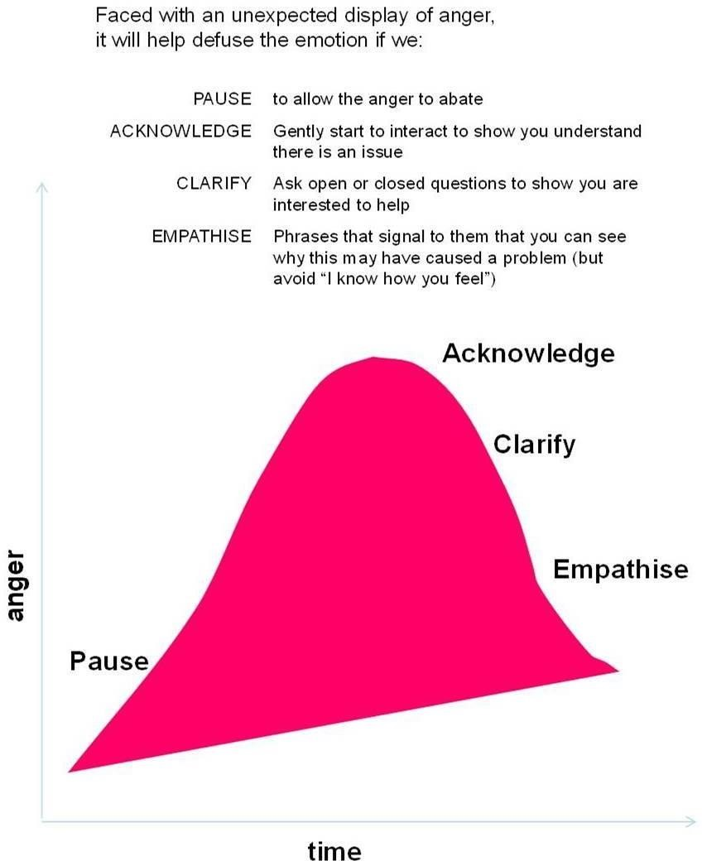

The five-step appeal

This model is used to de-escalate conflict. It is useful when resolving a difficult situation or where a person refuses to comply with a request to change their behaviour.

**ETHICAL APPEAL**

Start by making a reasonable request of somebody.

**REASONED APPEAL**

Give the person the reason / understanding as to why you are making the request.

**PERSONAL APPEAL**

How will the person benefit

## PRACTICAL APPEAL

The last chance to get the person to stop what they are doing. Offer alternatives / options / consequences.

## ACTION

Make sure you do what you said you are going to do, but don’t make threats!

### Communication is not just about words

In 1971, psychologist Albert Mehrabian published his most famous but often misquoted research on communication. This research, which is still relevant today, emphasised the importance of non-verbal communication, referring to the signals that we give another person and the way we interpret the signals given by them.

In order to get our message across in the most effective possible way, we need to ensure that our tone of voice and body language match the spoken information:

Visual = how you look, your body language, facial expressions and hand gestures

Verbal = the content, the actual words you say

Vocal = the way in which you deliver the words (tone, pitch, etc.)

If these are in the right proportion, they become bigger than the sum of their three parts – and the message becomes more powerful.

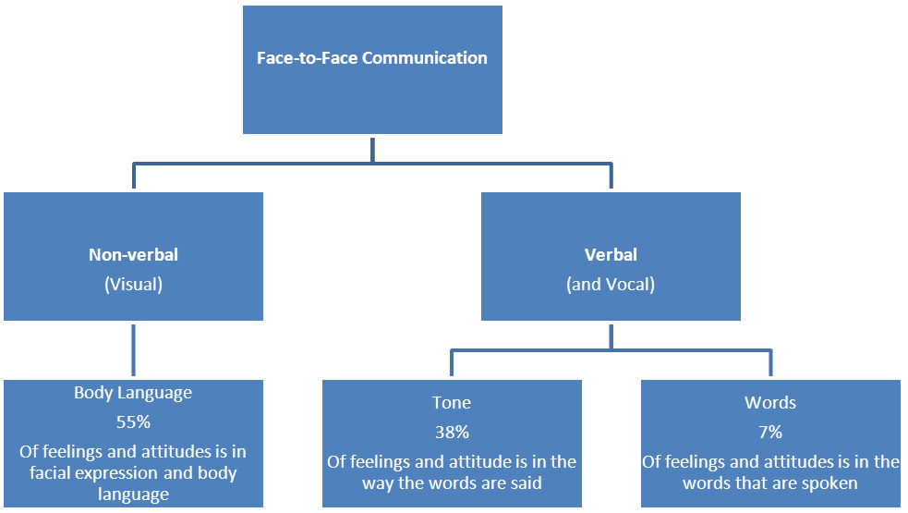

In order to get the Visual right we need to ensure:

* We have the right posture (upright, not tense – which would restrict the delivery)
* We have the right physical expression (relaxed and controlled as opposed to tense, inhibited or aggressive)

In order to get the Verbal right we need to ensure:

* We know what we’re doing, we’ve done our homework in terms of the product knowledge
* As well as ensuring we’ve pitched it right for the target audience

In order to get the Vocal right we need to ensure:

* We deliver the words with the right • Volume (‘strong’ doesn’t have to be ‘loud’)
* Tone (confident and appropriate for the message)
* Pitch (high or low)
* Pace (speed to match the message)
* Intonation pattern (varied to keep the audience engaged)

We do not have to be experts in body language to ‘get the picture’ and it is worth remembering that while we may form an impression of someone before they even speak, they are also forming a first impression of us.

### Attitude and Behaviour Cycle (Betari's Box)

Negative attitude and negative behaviour can become a vicious circle. Without the knowledge of this concept we can become locked into an escalating cycle of confrontation that becomes emotional. How we think and feel about ourselves and situations affects our conscious and subconscious behaviour such as our body language. This then Impacts on the other person's attitude and affects their behaviour.

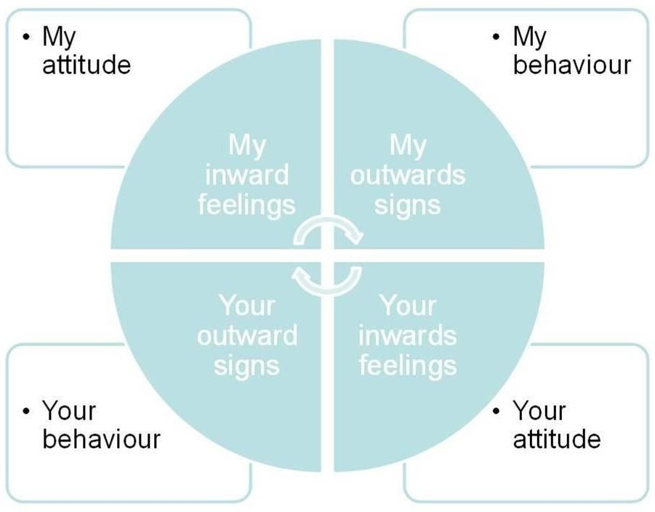

We each have a responsibility to override whatever feelings we may be experiencing, and move towards a more positive and rational outlook. Once we understand this concept we are then empowered to break the cycle and use the messages that we send to de-escalate the interaction and promote a positive exchange.

### What can we do if communication will not work? Be Aware – Assess – Plan

We have looked at how we communicate with others and how this can influence their behaviour and help to de-escalate a conflict situation.

Different models of communication can act as tools to assist in conflict resolution and in recognising the behaviours people can exhibit, helping us to make decisions about our own actions.

**Compliance**

–

the

person

will

offer

no

resistance

and

complies

with

your request

**Verbal resistance**

**and**

**gestures**

–

the

person refuses

to

comply either verbally

or

with

|  |  |
| --- | --- |
| Be aware | Be alert; constantly observe what is going on around you |
| Assess | Acknowledge that situations can change rapidly and will call for regular assessment |
| Plan | Prepare for unforeseen circumstances |

If all else fails we recognise that there will be some situations that we will not be able to resolve and that there may be times when the other person’s behaviour may become threatening, abusive or even violent.

When responding to these challenges, our first consideration should be our own

safety and, in doing so, we have to decide between ‘Flight’ and ‘Fight’. This is the

body’s natural reaction to a potentially dangerous situation. It produces adrenalin to

enable flight or fight.

**Flight**:

* Flight should always be the preferred option.
* Never stay in a situation in which you feel uncomfortable.
* Duty of care starts with you.
* Better to hand over your bag to the mugger and stay safe.
* Keep exits clear.
* Make an excuse to leave the room.

**Fight**:

* Leave a “way out” wherever possible. • Ensure all action is within the law.

### Techniques to prevent or diffuse conflict

The ability to identify potential causes of conflict, and to know how to respond to them, will help you to diffuse difficult situations. This will make your job easier and safer and will ensure a better outcome for patients.

### Understanding behaviour

There will be situations when people you come into contact will demonstrate one of the following behaviours.

their body language

**Passive resistance** – the person will either sit or stand and will not move

**Active resistance** – the person pulls away or pushes you, but makes no attempt to strike

**Aggressive resistance** – the person physically attacks you

**Serious or aggravated resistance** – the person causes serious injury and may use weapons

People will *normally* progress through these stages but may jump through them without warning. Recognising these patterns may assist you in deciding upon an appropriate response.

### Warning and danger signs

The table below identifies some of the physiological changes people will undergo which will indicate that they are becoming aggravated and may assist you with your response.

|  |  |
| --- | --- |
| **Warning signs**  *(if you can deal with these then they may never become danger signs)* | **Danger signs**  *(you need to think of your escape plan)* |
| Direct prolonged eye contact | Fists clenching and unclenching |
| Facial colour may darken | Facial colour may pale |
| Head is back | Lips tighten over teeth |
| Subject stands tall | Head drops to protect throat |
| Kicking the ground | Eyebrows droop to protect eyes |
| Large movements close to people | Hands rise above waist |
| Breathing rate accelerates | Shoulders tense up |
| Behaviour may stop/start abruptly | A sideways stance is adopted |
| Stare is now at intended target |
| Lowering of body to launch forward. |

### 

### Impact factors

In order to decide how to address a conflict situation, you need to consider the impact factors that make any situation potentially more dangerous. Impact factors can relate to the people involved in the situation, objects present and the environment in which you find yourself.

|  |  |  |
| --- | --- | --- |
| **People** | **Objects** | **Environment** |
| Gender, age, size of person | Alcohol or drugs | Time of day: daylight or evening |
| Mental state, Mood, Tiredness | Potential weapons | Safe exits for escape |
| Numbers of people present: ‘more’ does not always mean ‘safer’ | Offensive weapons | Distance and space |

If you are able to assess the impact factors it will help you answer the question: “Should I deal with this person, or is the better course of action to remove myself from the situation and then raise the alarm?”

Distance and space can be considered to be key impact factors when dealing with conflict. If you leave distance between yourself and the other person this can give you time to think and then react. Space relates to how close you can get to someone before they feel uncomfortable. You will naturally allow certain people closer and often give other people a wide berth. Remember that there will be cultural/religious differences. Within the work environment, however, caring for someone often means invading their personal space and it is important to remember that this can make them feel uncomfortable or anxious.

### The Law

In the unusual case where you do have to defend yourself, you must do so within the law. **Common Law** states that you must use the Minimum use of force. The courts will interpret the Proportionality of force used and the Seriousness of evil to be prevented. You also have the right of self-defence. **Section 3 of the Criminal Law Act 1967**, states that you must use force that is “reasonable in the circumstances”. The courts will decide what is ‘reasonable’.

In conclusion, think about what the word ‘conflict’ means to you; what your experience of it has been and how you may deal with conflict more effectively in the future in light of the above information.

*Have you……*

*Read all of the guidance? Yes/No*

*Checked that you have read*, *understood and are able to apply in your role? Yes/No*

Please read this guidance document and confirm your understanding by completing the return slip and returning this to your site specific training department for us to update your ESR records.

Alternatively, you can email your completed form to:

**Bedford:** [educationcentrebookings@bedfordhospital.nhs.uk](mailto:educationcentrebookings@bedfordhospital.nhs.uk)

**Luton:** [trainingbookings@ldh.nhs.uk](mailto:trainingbookings@ldh.nhs.uk)

|  |  |
| --- | --- |
| Full Name    (please  Print) |  |
| Department |  |
| Topic | Conflict Resolution |
| Date Read/ Completed |  |
| Signature |  |