

**Safeguarding Adults, Basic Prevent Awareness and MCA/ DoLs Workbook**

**Introduction**

Bedfordshire Hospitals NHS Trust is committed to meeting its responsibilities to ensure safe practice in accordance with; The Care Act (2014), The Mental Capacity Act (2005) and

The Prevent Agenda. All staff, including unpaid and voluntary are required to complete Safeguarding adult training.

**Learning Objectives:**

**The learner will be able**:

*To explore what is Safeguarding adults and who are we safeguarding?

*To understand your role when safeguarding adults.

*To increase awareness of the safeguarding adult referral process.

*To identify appropriate information sharing.

*To increase awareness of the principle of Making Safeguarding Personal.

*To promote use of Advocacy.

*To review the MCA/Best interest process

*To discuss application of DOLS

*To explore basic Prevent awareness

**Section 1: What is Safeguarding Adults?**

Adult safeguarding is working with an individual to protect their rights to live in safety, free from abuse, harm or neglect. This can include both proactive and reactive interactions to support health and wellbeing with the engagement of the individual and their wider community. The aim is to enable the individual to live free from fear and harm and have their rights and choices respected.

**Section 2: Who are we safeguarding?**

Safeguarding Adults applies to anyone of the age of 18 years or over.

The Care Act (2014) is a piece of legislation that dictates who we should be safeguarding. Adults are categorized by the three stage test as follows:

Version 1- October 2021

* An adult who has care and support needs;
* and are at risk of or have experienced abuse, neglect or harm
* and because of their care and support needs are unable to protect themselves.

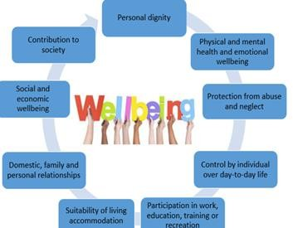**Section 3: Patient Vulnerabilities**

These can include:

* Learning disabilities
* Mental health problems
* Long term chronic conditions
* Frailty
* Drug and alcohol abuse
* Domestic violence

These can be influenced by **Environmental factors such as:**

* + Social isolation
  + Poverty
  + Inadequate housing
  + Cognitive impairment
  + Sensory deficit
  + Children/family

•

All vulnerabilities can heighten the risk of abuse, neglect or harm to patients. Making the adult more susceptible to being abused.

It is important to look at our patients holistically and as a whole. If we consider the Care Act’s Wellbeing principle all of these areas are important to maintain our own wellbeing. Wellbeing is a broad concept applying to several areas of life, not only to one or two. Therefore, using a holistic approach to ensure a clear understanding of the individual’s and their views.

**Section 4: Types of Abuse**

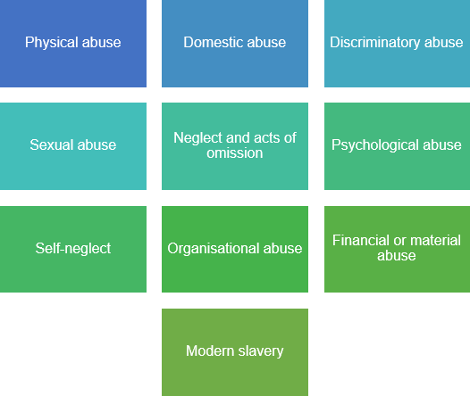

**Types of physical abuse**

Assault, hitting, slapping, punching, kicking, hair-pulling, biting, pushing, Rough handling, Scalding and burning, Physical punishments, Inappropriate or unlawful use of restraint, Making someone purposefully uncomfortable (e.g. opening a window and removing blankets), Involuntary isolation or confinement Misuse of medication (e.g. over-sedation), Forcible feeding or withholding food.

**Possible indicators of physical abuse**

No explanation for injuries or inconsistency with the account of what happened,

Injuries are inconsistent with the person’s lifestyle, Bruising, cuts, welts, burns and/or marks on the body or loss of hair in clumps, frequent injuries, unexplained falls, Subdued or changed behaviour in the presence of a particular person, Signs of malnutrition, Failure to seek medical treatment or frequent changes of GP.

**Types of domestic violence or abuse**

Domestic violence or abuse can be characterized by any of the indicators of abuse outlined relating to: psychological, physical, Sexual and financial.

Domestic violence and abuse includes any incident or pattern of incidents of controlling, coercive or threatening behaviour, violence or abuse between those aged 16 or over who are or have been, intimate partners or family members regardless of gender or sexuality. It also includes so called 'honour’ -based violence, female genital mutilation and forced marriage.

Coercive or controlling behavior is a core part of domestic violence. Coercive behaviour can include: acts of assault, threats, humiliation and intimidation, harming, punishing, or frightening the person, isolating the person from sources of support, exploitation of resources or money, preventing the person from escaping abuse, regulating everyday behaviour.

**Possible indicators of domestic violence or abuse**

Low self-esteem, Feeling that the abuse is their fault when it is not, Physical evidence of violence such as bruising, cuts, broken bones, Verbal abuse and humiliation in front of others, Fear of outside intervention Damage to home or property, Isolation – not seeing friends and family, Limited access to money.

**Types of sexual abuse**

Rape, attempted rape or sexual assault, Inappropriate touch anywhere, Non- consensual masturbation of either or both persons, Non- consensual sexual penetration or attempted penetration of the vagina, anus or mouth, Any sexual activity that the person lacks the capacity to consent to, Inappropriate looking, sexual teasing or innuendo or sexual harassment, Sexual photography or forced use of pornography or witnessing of sexual acts, Indecent exposure.

**Possible indicators of sexual abuse**

Bruising, particularly to the thighs, buttocks and upper arms and marks on the neck, Torn, stained or bloody underclothing, Bleeding, pain or itching in the genital area, Unusual difficulty in walking or sitting Foreign bodies in genital or rectal openings, Infections, unexplained genital discharge, or sexually transmitted diseases, Pregnancy in a woman who is unable to consent to sexual intercourse,

The uncharacteristic use of explicit sexual language or significant changes in sexual behaviour or attitude, Incontinence not related to any medical diagnosis, Self-harming, Poor concentration, withdrawal, sleep disturbance, Excessive fear/apprehension of, or withdrawal from, relationships, Fear of receiving help with personal care, Reluctance to be alone with a particular person.

**Types of psychological or emotional abuse**

Enforced social isolation – preventing someone accessing services, educational and social opportunities and seeing friends, Removing mobility or communication aids or intentionally leaving someone unattended when they need assistance, Preventing someone from meeting their religious and cultural needs, Preventing the expression of choice and opinion, Failure to respect privacy, Preventing stimulation, meaningful occupation or activities, Intimidation, coercion, harassment, use of threats, humiliation, bullying, swearing or verbal abuse, Addressing a person in a patronising or infantilising way, Threats of harm or abandonment, Cyber bullying.

**Possible indicators of psychological or emotional abuse**

An air of silence when a particular person is present, Withdrawal or change in the psychological state of the person, Insomnia, Low self-esteem, Uncooperative and aggressive behaviour, A change of appetite, weight loss/gain, Signs of distress: tearfulness, anger, Apparent false claims, by someone involved with the person, to attract unnecessary treatment.

**Types of financial or material abuse**

Theft of money or possessions, Fraud, scamming, Preventing a person from accessing their own money, benefits or assets, Employees taking a loan from a person using the service, Undue pressure, duress, threat or undue influence put on the person in connection with loans, wills, property, inheritance or financial transactions, Arranging less care than is needed to save money to maximise inheritance,

Denying assistance to manage/monitor financial affairs, denying assistance to access benefits, Misuse of personal allowance in a care home, Misuse of benefits or direct payments in a family home, someone

moving into a person’s home and living rent free without agreement or under duress, False representation, using another person's bank account, cards or documents, Exploitation of a person’s money or assets, e.g. unauthorised use of a car, Misuse of a power of attorney, deputy, appointeeship or other legal authority Rogue trading – e.g. unnecessary or overpriced property repairs and failure to carry out agreed repairs or poor workmanship.

**Possible indicators of financial or material abuse**

Missing personal possessions, Unexplained lack of money or inability to maintain lifestyle, Unexplained withdrawal of funds from accounts, Power of attorney or lasting power of attorney (LPA) being obtained after the person has ceased to have mental capacity, Failure to register an LPA after the person has ceased to have mental capacity to manage their finances, so that it appears that they are continuing to do so

The person allocated to manage financial affairs is evasive or uncooperative, The family or others show unusual interest in the assets of the person, Signs of financial hardship in cases where the person’s financial affairs are being managed by a court appointed deputy, attorney or LPA, Recent changes in deeds or title to property, Rent arrears and eviction notices, A lack of clear financial accounts held by a care home or service, Failure to provide receipts for shopping or other financial transactions carried out on behalf of the person, Disparity between the person’s living conditions and their financial resources, e.g. insufficient food in the house, Unnecessary property repairs.

**Types of modern slavery**

Human trafficking, Forced labour, Domestic servitude, Sexual exploitation, such as escort work, prostitution and pornography, Debt bondage – being forced to work to pay off debts that realistically they never will be able to.

**Possible indicators of modern slavery**

Signs of physical or emotional abuse, appearing to be malnourished, unkempt or withdrawn

Isolation from the community, seeming under the control or influence of others, living in dirty, cramped or overcrowded accommodation and or living and working at the same address, Lack of personal effects or identification documents, Always wearing the same clothes, Avoidance of eye contact, appearing frightened or hesitant to talk to strangers, Fear of law enforcers.

**Types of discriminatory abuse**

Unequal treatment based on age, disability, gender reassignment, marriage and civil partnership, pregnancy and maternity, race, religion and belief, sex or sexual orientation (known as [‘protected](http://www.equalityhumanrights.com/advice-and-guidance/new-equality-act-guidance/protected-characteristics-definitions/) [characteristics’ under the Equality Act 2010](http://www.equalityhumanrights.com/advice-and-guidance/new-equality-act-guidance/protected-characteristics-definitions/)).

Verbal abuse, derogatory remarks or inappropriate use of language related to a protected characteristic Denying access to communication aids, not allowing access to an interpreter, signer or lip-reader Harassment or deliberate exclusion on the grounds of a protected characteristic, Denying basic rights to healthcare, education, employment and criminal justice relating to a protected characteristic Substandard service provision relating to a protected characteristic.

**Possible indicators of discriminatory abuse**

The person appears withdrawn and isolated, Expressions of anger, frustration, fear or anxiety

The support on offer does not take account of the person’s individual needs in terms of a protected characteristic.

**Types of organisational abuse**

Discouraging visits or the involvement of relatives or friends, Run-down or overcrowded establishment Authoritarian management or rigid regimes, Lack of leadership and supervision, Insufficient staff or high turnover resulting in poor quality care, Abusive and disrespectful attitudes towards people using the service, Inappropriate use of restraints, Lack of respect for dignity and privacy, failure to manage residents with abusive behaviour, Not providing adequate food and drink, or assistance with eating, Not offering choice or promoting independence, Misuse of medication, Failure to provide care with dentures, spectacles or hearing aids, Not taking account of individuals’ cultural, religious or ethnic needs, Failure to respond to abuse appropriately, Interference with personal correspondence or communication, Failure to respond to complaints.

**Possible indicators of organisational abuse**

Lack of flexibility and choice for people using the service, Inadequate staffing levels, People being hungry or dehydrated, Poor standards of care, Lack of personal clothing and possessions and communal use of personal items, Lack of adequate procedures, Poor record-keeping and missing documents, Absence of visitors, Few social, recreational and educational activities, Public discussion of personal matters, Unnecessary exposure during bathing or using the toilet, Absence of individual care plans, Lack of management overview and support.

**Types of neglect and acts of omission**

Failure to provide or allow access to food, shelter, clothing, heating, stimulation and activity, personal or medical care, Providing care in a way that the person dislikes, Failure to administer medication as prescribed, Refusal of access to visitors, Not taking account of individuals’ cultural, religious or ethnic needs, Not taking account of educational, social and recreational needs, Ignoring or isolating the person Preventing the person from making their own decisions, Preventing access to glasses, hearing aids, dentures, etc. Failure to ensure privacy and dignity.

**Possible indicators of neglect and acts of omission**

Poor environment – dirty or unhygienic, Poor physical condition and/or personal hygiene, Pressure sores or ulcers, Malnutrition or unexplained weight loss, Untreated injuries and medical problems, Inconsistent or reluctant contact with medical and social care organisations, Accumulation of untaken medication, Uncharacteristic failure to engage in social interaction, Inappropriate or inadequate clothing.

**Types of self-neglect**

Lack of self-care to an extent that it threatens personal health and safety, Neglecting to care for one’s personal hygiene, health or surroundings, Inability to avoid self-harm, Failure to seek help or access services to meet health and social care needs, Inability or unwillingness to manage one’s personal affairs.

**Indicators of self-neglect**

Very poor personal hygiene, unkempt appearance, Lack of essential food, clothing or shelter,

Malnutrition and/or dehydration, Living in squalid or unsanitary conditions, Neglecting household maintenance, Hoarding, Collecting a large number of animals in inappropriate conditions, Non-compliance with health or care services, Inability or unwillingness to take medication or treat illness or injury.

**Section 5: Where Does Abuse Occur?**

**Everywhere.**

* + Human trafficking (The Modern Slavery Act, 2015)
  + Radicalisation (Counter-Terrorism and Security Act (2015)
  + Modern slavery (The Modern Slavery Act, 2015)
  + FGM (female genital mutilation act, 2003; Serious crime act, 2015)
  + Honour Base Violence (Serious Crime act, 2015)
  + Forced marriage (Anti-social behaviour, crime and policing act, 2014)
  + Domestic Violence (Serious Crime act, 2015)
  + Discrimination
  + Hate Crime (Police Hate Crime strategy, 2014)
  + Cyber Abuse
  + Homeless
  + Hoarding
  + Organisational- paid carer/ healthcare staff/ colleague/ agency/locum/volunteer

Abuse can happen anywhere, by anyone. It could be a paid member of staff, a carer, friend or family member. Domestic violence/abuse, modern day slavery and self-neglect are new categories of abuse since the Care Act was implemented in 2014. The impact of abuse can be detrimental and wide spanning to the individual and/or their family/friends/carers.

**Section 6: Six Principles of Safeguarding**

**Six Principles of Safeguarding**

* **Empowerment** – Personalisation and the presumption of person-led decisions and informed consent.
* **Prevention** – It is better to take action before harm occurs.
* **Proportionality** – Proportionate and least intrusive response appropriate to the risk presented.
* **Protection** – Support and representation for those in greatest need.
* **Partnership** – Local solutions through services working with their communities. Communities have a part to play in preventing, detecting and reporting neglect and abuse.”
* **Accountability** – Accountability and transparency in delivering safeguarding.

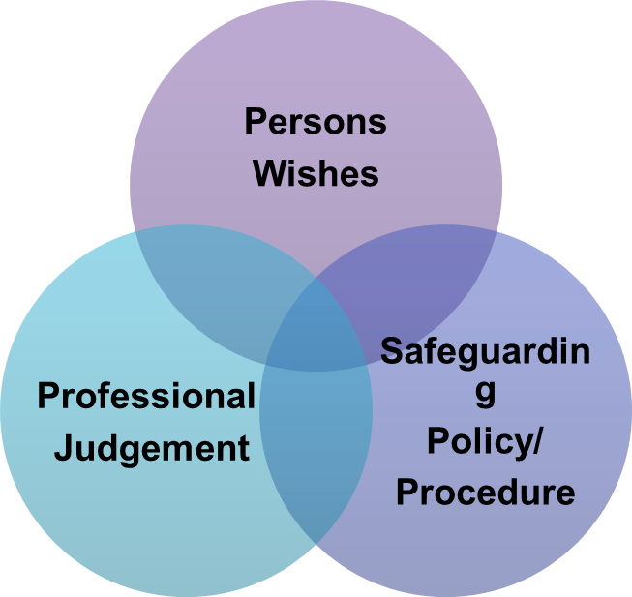

**Section 7: Making Safeguarding Personal**

An approach that is:

* Person centred / led.
* Focused on outcomes the person wants.
* Strengths based.
* Aimed at enhancing the person’s involvement, choice & control.
* Focused on improving quality of life and safety directly.

**Section 8: Reporting Abuse**

**(L&D Site)**

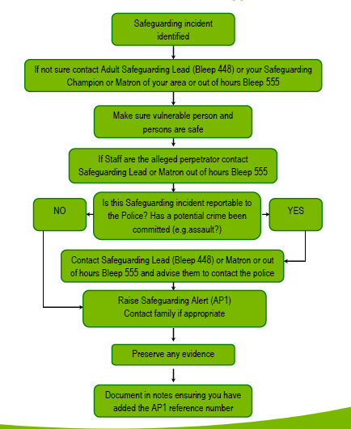

**(Bedford Site)**

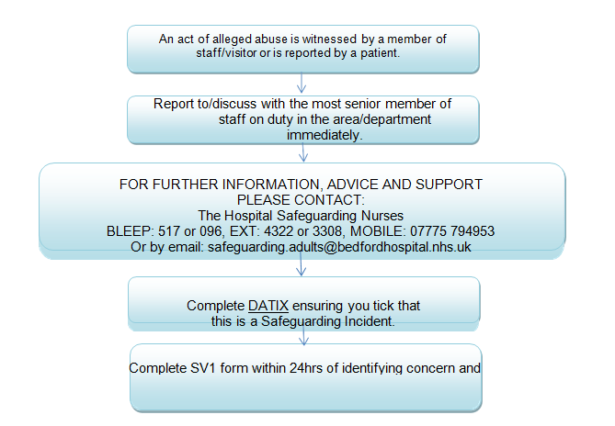

**Remember to consider:**

* Risk to others
* Risk to the patient
* Mental Capacity

**Section 10: What Happens Next?**

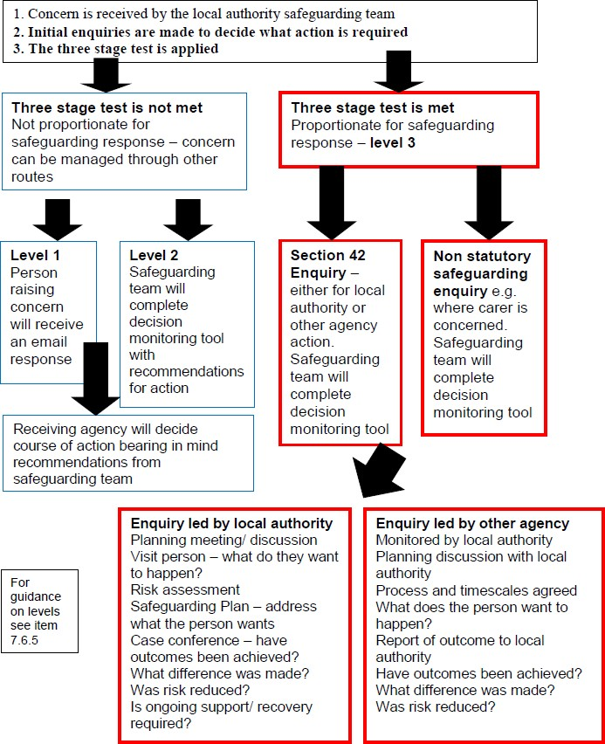

**Section 11: Basic Prevent Awareness**

The strategy aims to prevent people from being drawn into terrorism and ensure that they are given appropriate advice and support. To work with sectors and institutions where there are risks of radicalisation that we need to address.

Radicalisation- “the action or process of causing someone to adopt radical positions on political or social issues”

Healthcare workers have the opportunity to refer vulnerable individuals for support in a pre-criminal space by:

* + recognising vulnerable adults, children and young people who may be at risk of radicalisation,
  + working in partnership to reduce risk and protect the individual and
  + providing adequate and necessary support as part of a proportionate multi-agency response to any concerns.

This is not about race, religion or ethnicity-the programme is to prevent the exploitation of susceptible people.

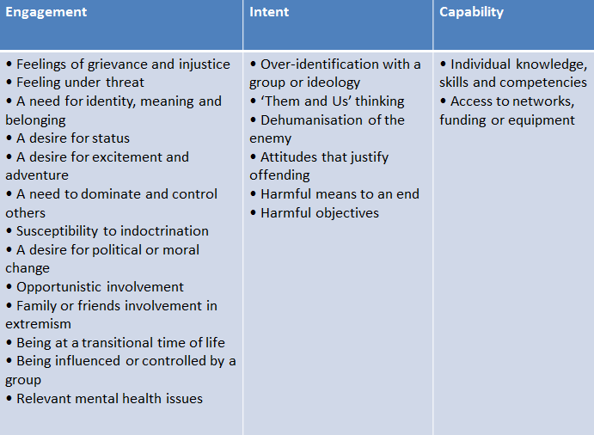

**Section 12: Mental Capacity**

The phrase ‘Mental Capacity’ used in the act refers to our ability to make decisions. These can be everyday decisions about what to eat or wear. They can also be bigger decisions about place of residence, financial decisions or decisions about medical treatment.

**Who does it apply to?**

* + The Mental Capacity Act (MCA) is a piece of legislation that came into force in 2005.
  + The Act applies to anyone over the age of 16 who lives in England or Wales.

**Purpose of the Act**

It provides a legal framework for adults to make a decision about their lives in two ways:

1. The Act says people have the right to make their own decisions wherever possible. If they are unable to make decisions, then others may need to act for them but the adult must remain at the centre of any decisions made in their **best interests.**
2. The Act also provides ways in which people (or in some circumstances their families) can plan ahead for decisions that need to be taken in their best interests.

**Fluctuating Capacity**

* + The Mental Capacity Act recognises that some people have the ability to make simple

decisions but not complex decisions or that their ability to make decisions can vary from day to day or even during the day. This is known as **Fluctuating Capacity.**

* + **Any decision taken about a person’s capacity is always taken in relation to a particular decision at a given time.**

**Section 13: Principles of the Mental Capacity Act**

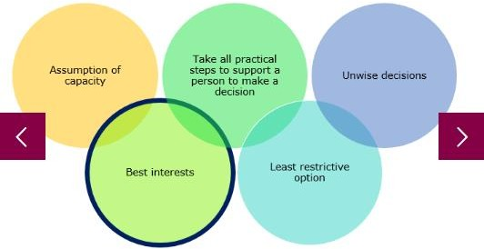

**Principle 1** *A presumption of capacity*

Every adult has the right to make his or her own decisions and must be assumed to have capacity to do so unless it is proved otherwise. This applies to adults whatever their ability or disability.

**Principle 2** *Individuals should be supported to make their own decisions*

An adult should not be treated as unable to make a decision unless all practicable steps to help them to do so has been taken without success.

**Principle 3** *Unwise decisions*

Adults have the right to make decisions that others might regard as unwise or eccentric. You cannot treat someone as lacking capacity simply because you disagree with their decision.

**Principle 4** *Best Interests*

When an adult does lack capacity to make their own decisions, others may make decisions on their behalf. Any decisions must be taken in their best interests.

**Principle 5** *Least Restrictive Option*

Any ‘best interest’ decision taken on behalf of an adult should interfere as little as possible with their rights and freedoms. Each decision has to take account of all the circumstances, and take the least restrictive course of action available.

**Section 14: Who Completes the Assessment and Best Interest Decision?**

The decision maker is the person or persons looking after the patient at the time the decision needs to be made

Decisions regarding medical treatment are made by the multi professional team caring for the patient lead by the Consultant.

Decisions regarding accommodation will be made by the social work team with input from the multi professional team.

**Section 15: Two Stage Test of Capacity**

When deciding whether a person has the mental capacity to make a particular decision, you must apply a two-stage test and show that it has been applied:

* + Stage 1: Decide whether or not there is an impairment of, or disturbance in, the functioning of the person’s mind or brain (it does not matter if this is permanent or temporary). This does not depend on having a medical diagnosis. The clinician must consider the evidence and come to a conclusion.

Possible outcomes:

* Stage 1 of the test is not met

If there is no identified impairment or disturbance in the functioning of the person’s mind or brain, the individual does not lack capacity within the meaning of the Act.

* Stage 1 the test is met

If there is impairment or disturbance, it is necessary to move on to stage two of the test below.

* + Stage 2: Is the impairment or disturbance sufficient to make the person unable to make the particular decision?

**Section 16: Does your patient have capacity?**

If the patient meets the criteria for the two stage test; we then need to determine if the patient has capacity to make the decision we need them to make. This is done by assessing whether the patient can:

* understand the information relevant to that decision
* retain that information (for long enough to use and weigh [see below])
* use or weigh that information as part of the process of making the decision
* communicate their decision (whether by talking, using sign language or any other means).

If the answer is ‘no’ to one or more of these questions then the patient lacks capacity to consent to the decision. We know need to make a best interest decision.

**Section 17: Best Interest Decisions**

All decisions must be made in the best interests of the person who lacks capacity.

Any best interest decisions relating to life-sustaining treatment must not be motivated by a desire to bring about the person’s death.

The decision maker must consider all relevant circumstances.

The Clinician making the Best Interest Decision should when completing a Best Interest Decision do the following:

* Encourage Participation of the patient
* Identify all relevant circumstances
* Find out the patients views including:
* Past and present wishes and feelings, Beliefs and values
* Avoid discrimination because of disability, age, sexuality, appearance or condition
* Assess whether capacity might be regained
* Any written statements of beliefs or feelings
* Any valid and applicable advance directives
* Least restrictive of basic rights and freedoms
* Consult both family and friends
* Weigh up all these factors in order to work out what is in the person’s best interests.

**Section 18: People who can support those who lack capacity**

* + Lasting Power of Attorney-these people are chosen by the person themselves to look after their health and welfare and/or financial decisions should they lack capacity at a later stage of their lifetime. This person is formally appointed by the Office of Public Guardian upon a

successful application being received.

If a patient or relative informs you they have a lasting power of attorney; please request a copy and place in patient’s notes. Ensure the Lasting Power of Attorney allows them to make the decision that is required.

For example someone who has a financial Power of Attorney cannot make decisions about Health Care treatment. It should be stamped by the Office of Public Guardian and have a reference number on it. If you doubt whether this document is valid, please contact the Safeguarding team in the hospital or contact the Office of Public Guardian with the appropriate reference number

* + Deputies appointed by the Court of Protection- This person is appointed by the court to make decisions, where the person does not have capacity to choose their own attorney. The court will agree on the powers the deputy has, according to the person circumstances.

**Section 19: Other ways the mental capacity act protects patients**

* + **The Court of Protection**-can make decisions affecting an adult who lacks capacity when there is no agreement on what is in the person’s best interests. The court is a last resort where a local agreement cannot be reached, or where the decision is so serious it can only be taken by the court.
  + **The Public Guardian**-the role of the office of public guardian is protect people who lack capacity from abuse and is supported by the Office of Public Guardian.
  + **Independent Mental Capacity Advocate (IMCA)-**IMCA’s are advocates who are available by right to some people who lack capacity to make important decisions such as change of accommodation or serious medical treatment when the patient does not have family or friends who can represent them. (Referrals form for the IMCA can be found on the intranet, on the safeguarding adult page).
  + **Advance Decisions to Refuse Treatment**-the act allows adult to make decisions in advance of treatment they do not wish to receive in case they lack capacity in the future

**Section 20: Restraint (Section 6, Mental Capacity Act)**

* + Any action intended to restrain a person who lacks capacity will not attract protection from liability unless the following two conditions are met:
* the person taking action must reasonably believe that restraint is necessary to prevent harm to the person who lacks capacity,
* the amount or type of restraint used and the amount of time it lasts must be a proportionate response to the likelihood and seriousness of harm
* Under some circumstances, the prolonged use of restraint, or restraint in conjunction with other restrictive measures, might amount to a “Deprivation of Liberty”.

**Section 21: Deprivation of Liberty**

The Deprivation of Liberty Safeguards (DoLs) is an amendment of the MCA act 2005.

The Mental Capacity Act allows restraint and restrictions to be used – but only if they are in a person's best interests and proportionate to the situation. Extra safeguards are needed if the restrictions and restraint used will deprive a person of their liberty. These are called the Deprivation of Liberty Safeguards.

Deprivation of Liberty applies only to people who do NOT have Mental Capacity.

Safeguards came into force on April 1st 2009. They are designed to ensure that a person’s loss of liberty is lawful.

There are 3 elements:

* + To provide the person with a representative.
  + To allow a right of challenge to the Court of Protection against the unlawful deprivation of liberty.
  + To provide a right for deprivation of liberty to be reviewed and monitored frequently.

A Patient is being deprived of their liberty if the following applies to their current situation:

“The person is under continuous supervision and control and is not free to leave, and the person lacks capacity to consent to these arrangements” (referred to as the Acid Test)

(Superior Court Ruling, March 2014)

If you feel that the acid test applies to your patient then a request for an **Urgent and Standard**

**Authorisation (FORM 1)** needs to be completed and emailed or faxed to the local authority where your patient usually resides. This form can be found on the intranet, on the safeguarding adult page.

**Section 22: Advocacy**

**Independent Mental Capacity Advocate (IMCA)**

An IMCA is an advocate who has been specially trained to support people who are not able to make certain decisions for themselves and do not have family or friends who are able to speak for them. This could be because the family are not acting in their best interest or there is no family to contact. IMCAs do not make decisions and they are independent of the people who do make the decisions.

An IMCA can support anyone who is over 16 years old and who has been assessed as ‘lacking capacity’ to make a particular decision about their life.

An IMCA can be instructed (asked to represent a person) when a decision needs to be made about:

* **Serious medical treatment** - when we want to give new treatment, stop treatment that is already being given or when they do not want to start treatment

OR

* **A change of accommodation** - when the NHS or local council wants to move a person to hospital for more than 28 days or to other accommodation for more than 8 weeks.

It should also be considered whether it would be helpful for an IMCA to be instructed for two other issues:

* **Safeguarding Adults from Abuse** *–* when the NHS or local council receives a report of abuse and either the person reported to have been abused or reported to be the abuser lacks capacity to understand the plans being made to prevent the abuse. This is the only type of issue where the person can have family or friends to support them and still have IMCA support.
* **Care Reviews** *–* when the NHS or local council has arranged accommodation or wants to review arrangements for a person who lacks capacity.

IMCA’s find out as much as possible about the views and beliefs of the person referred to them. They have the right to meet the person privately and to see their health and care records. An IMCA considers all relevant information about the person then writes a report to help decision-makers reach decisions which are in the best interests of the person. Sometimes they might look at options which were not suggested by the professional or ask for a second medical opinion. An IMCA has the right to challenge any decision made.

To apply for an IMCA please complete the referral form on the intranet, safeguarding adult page. This will need to be sent to the email address listed on the form. Currently we use Pohwer who use working hours. They advise that they usually respond to referrals between 2-5 working days. If a decision is urgent and cannot wait this long. Then please complete the referral and contact the IMCA service to advise of this. If they are still unable to attend within the time frame the decision needs to be made then please make the

decision ensuring you have documented the clinical rationale why. If the decision can wait for the IMCA service then it should be delayed until the IMCA can attend.

**What is A Care Act Advocacy?**

The Care Act says that we must involve people in decisions about their care and support needs. If it would be difficult for someone to be involved without support then we must make sure they get the help they need (regardless whether they do or don’t have capacity). If the person doesn’t have someone who can help them they have the right to have an independent Care Act advocate.

Care Act advocates can support:

* Adults who need care and support
* Carers
* Children who are moving to adult care services

If when making a decision regarding care and support the patient would be considered to have ‘substantial difficulty’ being involved a care act advocate should be used. Substantial difficulty would be if you have problems with one or more of these:

* Understanding information about the decisions
* Remembering information
* Using the information to be involved in the decisions
* Being able to tell people your views, wishes and feeling

A decision would need to be made whether that patient has an ‘appropriate individual’ to support them, this could be their next of kin. It can be someone in your family or a friend but won’t be someone you don’t want to support you. It can’t be someone who is paid to look after you.

An advocate will support you to be involved as much as possible in decisions about your care

A Care Act Advocate can be requested by completing the referral form and sending it to the email address on the form.

*Have you……*

*Read all of the guidance? Yes/No*

*Checked that you have read*, *understood and are able to apply in your role? Yes/No*

Please read this guidance document and confirm your understanding by completing the return slip and returning this to your site specific training department for us to update your ESR records.

Alternatively, you can email your completed form to:

**Bedford:** [educationcentrebookings@bedfordhospital.nhs.uk](mailto:educationcentrebookings@bedfordhospital.nhs.uk)

**Luton:** [trainingbookings@ldh.nhs.uk](mailto:trainingbookings@ldh.nhs.uk)

|  |  |
| --- | --- |
| Full Name (please Print) |  |
| Department |  |
| Topic | **Safeguarding Adults,**  **Basic Prevent awareness**  **and**  **MCA/DOLS Workbook** |
| Date Read |  |
| Signature |  |