**Fire Safety Information**

**Luton and Dunstable Hospital**

# Fire safety training is an annual statutory and legal requirement for all members of staff.

We all have a responsibility to play our part in maintaining a safe and healthy environment for our patients, staff and visitors.

A crucial and fundamental part of achieving this is for you to be up to date and continue each year with your compulsory fire training.

Please take the time to read this guidance document which will help to prepare you for your role at Luton & Dunstable Hospital (LDH).

Thank you

L&D - Health & Safety Manager

**Fire Safety - Do something about it**

## Staff Action Procedure

If you see, smell and think there is a fire - break the glass at the nearest fire alarm call point to alert everyone.

## Raise The Alarm

* Break the glass on the nearest fire alarm call point;

## Move People To Safety

* Keep calm;
* Move quickly and quietly;
* Provide reassurance to others;
* Encourage people to self evacuate by walking if they can;
* Utilise walking aids, wheelchairs, chairs with wheels, trollies and beds;
* Evacuate to a safe horizontal area within your Ward / Departmental areas behind either 30 or 60 minute fire doors;
* Tackle the fire if safe to do so, you do not risk your personal safety;
* Do not go back into a room where you have closed the door;
* Muster at your designated fire assembly points;
* Carry out duties as directed by your Department Manager / Supervisors.

## Fire - What Can You Do About It ...?

* You will receive fire safety information as part of your formal induction training;
* You should also receive a local induction carried out by Department Managers / Supervisors highlighting the fire safety features within your workplace;
* Talk to your Line Manager or colleagues, they will advise you about the fire procedures and fire precautions in your Ward or Department;
* Ensure your manadatory attendance at annual fire safety refresher training sessions;
* Do not be frightened to ask questions about fire safety in the area where you work - everyone will be pleased to help;
* Know what to do when you hear the fire alarm sounding;
* Be aware of the two different fire alarm sounds and what they mean to you;
  + **Signal One** - Intermittent alarm means that the fire is in an adjacent area;
  + **Signal Two –** Continuous alarm means that the fire is in your area

**Signal Two Fire Alarm - Fire Evacuation**

* Stop what you are doing .
* Make safe any machine you are using, consider switching off at the mains if safe or practicable to do so.
* Commence evacuation - Do exactly what you are told by the person in charge of your Ward / Department or by the Fire and Rescue Service when in attendance.

## Fire - Help is at Hand …

* LDH has fire extinguishers positioned around the Hospital to deal with a fire quickly;
* You will never be far away from a fire extinguisher, no matter where you are;
* Do you know where your fire extinguisher points are?

There are four main types of fire extinguishers in general use at Bedford Hospital.

* Carbon Dioxide Extinguisher (CO2), (black band) a gas which smothers fires, mainly used on electrical fires;
* Water Extinguisher (completely red) can be used on wood, paper and textiles;
* Foam Extinguisher (cream band) can be used on wood, paper, textiles and flammable liquids;
* Dry Powder Extinguisher (blue band) can be used on most all types of fire.

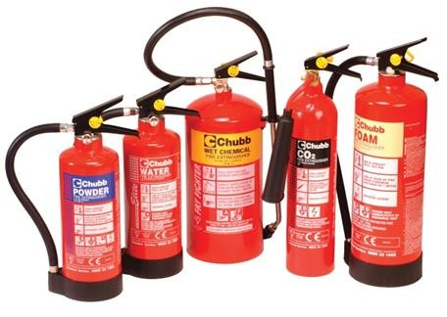

## classes of fire.jpgClassifications of Fire

**What Happens When The Fire Alarm Sounds …**

* Be aware of automatic fire doors closing without warning on the actuation of the fire alarm signals;
* If appropriate and safe to do so, inform Switchboard on Ext 3333 the exact location of fire;
* LDH Switchboard will call Bedfordshire Fire and Rescue Service.
* LDH Switchboard will alert LDH Fire Response Team consisting of 555 Bleep Holder, Estates Staff, Porters, Security and others as required
* Do not put yourself or others at risk by remaining at the scene;
* Always ensure you have a clear escape route;
* If safe to do so and properly risk assessed attempt to extinguish the fire using the correct extinguisher.

## Fire - How You Can help To Prevent It …

Reducing stocks and emptying bins more often helps reduce fire risk - you should also check:

* Heaters, lamps, cookers and hot surfaces. Make sure they are kept clear of combustible materials such as papers, towels and other linen;
* Don’t forget to check beds and furniture, they should not be close to things that can cause them to catch fire;
* Check all electrical items to ensure they have been PAT tested;
* Aerosols have warnings on them such as ‘flammable’ or ‘keep away from heat and flames - lessen the risk by reducing numbers in stock and ensure they are stored properly;
* Consider how you store items, too much or too many can increase fire risks. Keep the stock of bandages etc, especially flammable items, sealed in their boxes until they are needed;
* All flammable items **must** be locked away in a metal or approved storage cupboards.

## Fire - How You Can Keep People Safe ...

* + Fire safety affects every one of us;
  + Even a small fire will disrupt work and cause stress to visitors and patients alike;
  + Most if not all fires can be prevented if care is taken;
  + Make sure you read ‘Fire Action Notice’. Do you now what to do in the event of a fire ?
  + Check your escape routes on a regular basis, make sure they are clear at all times. You never know when you will need them in an emergency.

## Fire - How You Can Prevent It …

* + Noticeboards in Wards and Departments should be checked to ensure that information is up to date. Help reduce the risk of fire by keeping noticeboards tidy;
  + Oxygen is used to treat some patients to speed their recovery. Oxygen increases a fires intensity and will burn brighter and much hotter than usual;
  + Be aware that oxygen can turn a spark into a flame instantly. Patients often wear an oxygen masks that are connected by a tube to the piped oxygen supply in Wards and Theatres. Other patients wear masks and tubes connected to cylinder;
  + Keep all oxygen cylinders together when they are not being used;
  + Great care needs to be taken with oxygen make sure you keep it away from fire and from any ignition sources;
  + You can help prevent fires from by taking care and tidying up wherever you work;
  + LDH is a smoke free Hospital this includes E-cigarettes;
  + Electrical items must be PAT tested and labelled;
  + Check electrical wiring is well maintained and that sockets are never overloaded;
  + Flammable liquids should be treated with care at all times - keep them in the special stores / cabinets and take out only what you need, when you need it.

## Fire Safety Features Include:

* + Fire doors designed to hold fire and smoke back between 30 / 60 minutes on main routes;
  + Corridors and escape routes leading to fire exits must not be obstructed;
  + Final exits must be accessible at all times;
  + Smoke and heat detectors linked to the fire alarm systems;
  + Fire alarm call points all clearly marked with appropriate signage - find out where your nearest ones are;
  + Emergency lighting fitted which will light up escape routes if there is a power failure.

## How to Help People Evacuate Quickly and Safely - Here are some tips:

* + Act confidently and speak clearly, some people may have difficulty hearing you when the fire alarms are sounding - point to the fire exit doors;
  + Encourage people to evacuate the area. Each ward / department will have their own evacuation procedure - ensure you are fully aware of yours;
  + Encourage them to walk out if they can or they may need a walking aid;
  + Do not rush them unnecessarily but encourage them to move purposefully;
  + For those who can’t walk, utilise wheelcahirs, beds, trolly, wheelchairs, commodes, office chairs, ski pads etc;
  + Remember it is easier to push people on wheels then to drag them on a mattress;
  + If using a bed, remember in an emergency more than one person can travel on a bed.

## Fire - look for the signs ….

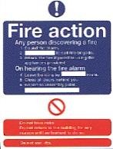 **Fire action notices detail what to do in the event of a fire**. 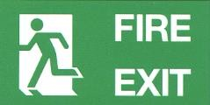 **Fire escape signs provides directional guidance.** 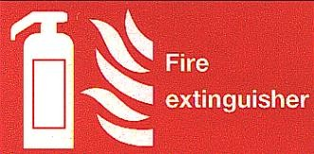 **Identifies locations of fire extingushers.**

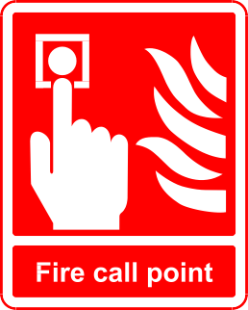 **Identifies positions and locations of break glass points.**

# LDH - Fire Assembly Points



*Have you……*

*Read all of the guidance? Yes/No*

*Checked that you have read*, *understood and are able to apply in your role? Yes/No*

Please read this guidance document and confirm your understanding by completing the return slip and returning this to your site specific training department for us to update your ESR records.

Alternatively, you can email your completed form to:

**Bedford:** [educationcentrebookings@bedfordhospital.nhs.uk](mailto:educationcentrebookings@bedfordhospital.nhs.uk)

**Luton:** [trainingbookings@ldh.nhs.uk](mailto:trainingbookings@ldh.nhs.uk)

|  |  |
| --- | --- |
| Full Name (please Print) |  |
| Department |  |
| Topic | **FIRE SAFETY** |
| Date Read |  |
| Signature |  |

Useful contact:

Luton & Dunstable Hospital Trust – Health & Safety :

Barry Harper Ext: 7030

[Barry.Harper@ldh.nhs.uk](mailto:Barry.Harper@ldh.nhs.uk)