C:\Users\pking\AppData\Local\Microsoft\Windows\INetCache\Content.Word\Bedfordshire-Hospitals-NHS-Foundation-Trust-2020-CMYK-(Right).jpg

Staff Health and Safety Handbook Bedfordshire Hospitals NHS Foundation Trust

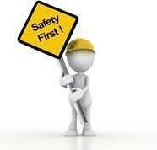

### Working together to improve Health and Safety:

The Trust has a duty of care to everyone that comes onto any of our sites; employees; visitors; patients and contractors.

Health and Safety at Work etc. Act1974: The Act applies to all workplaces in the UK;

The Act Places general duties on employers, manufacturers, employees and self- employed;

The Act Gives Inspectors strong powers of enforcement; and the inspectorate body is the Health and Safety Executive.

### Trust Health and Safety Policy:

Policy available on Trust Intranet

All employees are also under a duty to take reasonable care of their own health and safety and of others who may be affected by their acts or omissions.

The Trust has a moral and legal duty to staff, patients and visitors to provide a safe environment. The Trust must so far as reasonably practicable safeguard the Health, Safety and Welfare of all employees and should provide and maintain:

Safe work places, work equipment and safe systems of work.

Safe handling, storage, maintenance, transport and disposal of work articles and substances.

Any necessary information, instruction, training and supervision. The Trust must also so far as is reasonably practicable:

Take appropriate preventative/protective measures to safeguard health and safety.

Provide employees with health surveillance through the Occupational Health Department.

Appoint competent personnel to secure compliance with statutory duties.

### There are 4Cs’ that are critical in developing a positive safety culture?

Competence - Competence is the ability of an individual or group to fulfil a role properly and safely. It takes much more than training for someone to become competent, with experience having a significant influence.

Control - Control is about getting everyone to work together to achieve good health and safety performance. It starts at the top of an organisation, by nominating someone to have overall accountability.

Cooperation - Co-operation is achieved by allowing and encouraging everyone to participate in health and safety. This generates ownership and understanding. Also, it ensures knowledge and experience is built into solutions.

Communication - Communication is much more than sending out messages and assuming people receive them. Successful communication means that ‘receivers’ understand messages in the same as was meant by the ‘sender.’

### Definitions:

**Hazard;**

A hazard is anything that may cause harm e.g. chemicals, electricity, working from height, manual handling.

### Risk:

Risk is the likelihood, chance, high or low, of somebody being harmed by the hazard and how serious the harm could be.

Bedford Hospital Risk Matrix:

|  |  |  |  |  |  |
| --- | --- | --- | --- | --- | --- |
| FREQUENCY | CONSEQUENCE | | | | |
|  | 1 | 2 | 3 | 4 | 5 |
| INSIGNIFICENT | MINOR | MODERATE | MAJOR | CATASTROPHIC |
| 5 – ALMOST | **5** | **10** | **15** | **20** | **25** |
| CERTAIN |
| 4 – LIKELY | **4** | **8** | **12** | **16** | **20** |
| 3 – POSSIBLE | **3** | **6** | **9** | **12** | **15** |
| 2 – UNLIKELY | **2** | **4** | **6** | **8** | **10** |
| 1 – RARE | **1** | **2** | **3** | **4** | **5** |

Employees should read the Trust risk assessment policy where the matrix is explained in full.

Risk Assessment:

A risk assessment is simply a careful examination of what, in your work, could cause harm to people, so that you can weigh up whether you have taken enough precautions or should do more to prevent harm.

### There are 5 steps to any risk assessment:

Step 1 Identify the hazards

Step 2 Decide who might be harmed and how

Step 3 Evaluate the risks and decide on precautions

Step 4 Record your findings and Implement them

Step 5 Review your assessment at least annually and update, if necessary.

There are many types of risk assessment; for further information either read the Trust risk assessment policy or contact the Trust health, safety and welfare manager:

Barry Harpur

Barry.Harper@ldh.nhs.uk

**Hazard Spotting and Reporting:**

If you spot a health and safety hazard in your ward or department that you cannot resolve, then report it to the ward or departmental manager or health and safety representative.

Urgent hazards should also be reported to the Trust health, safety and welfare manager:

If the hazard requires assistance from maintenance; use the Trust maintenance log to report what is required; Urgent hazards should followed up with a phone call to the Maintenance manager.

### Electricity:

Electrical equipment is used extensively throughout the Trust and all employees should read the Trust Low Voltage Electricity Policy and Procedural document.

Employees should refrain from over loading plugs and sockets; site equipment sensibly, and ensure all electrical equipment is tested and inspected.

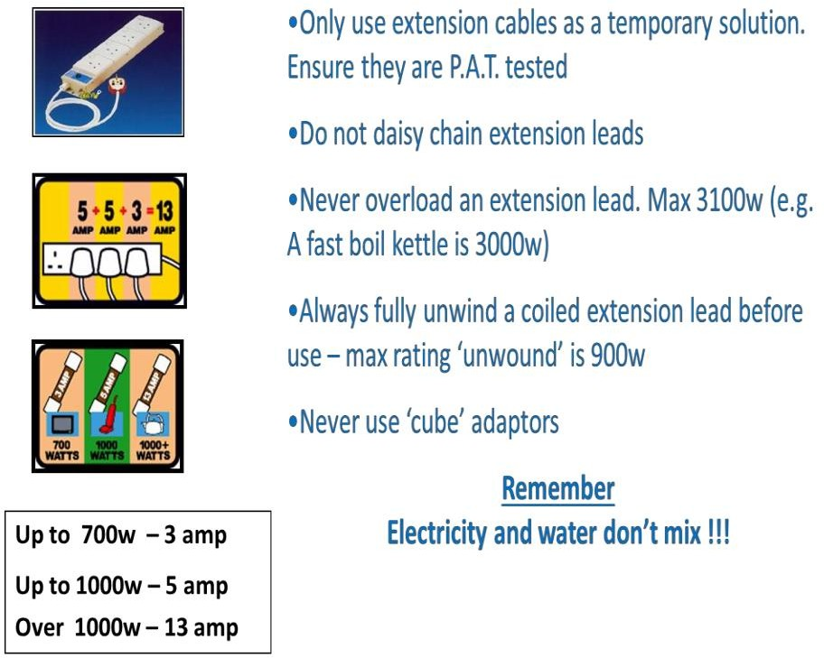

### Slips, Trips and Falls Prevention Tips:

* If you see a spillage, either clean it up, or make arrangements for it to be cleaned
* Report any damaged flooring or mats
* Play your part and keep the workplace tidy
* If you see items on the floor where someone could potentially trip over them, remove them or arrange for them to be removed or for the situation to be made safe
* If you have an accident or a near miss, make sure it is reported promptly. This information can be used to prevent future accidents.

Reporting Accidents/Incidents (Datix):

All accidents/Incidents and near misses must be reported using the incident reporting form (Datix).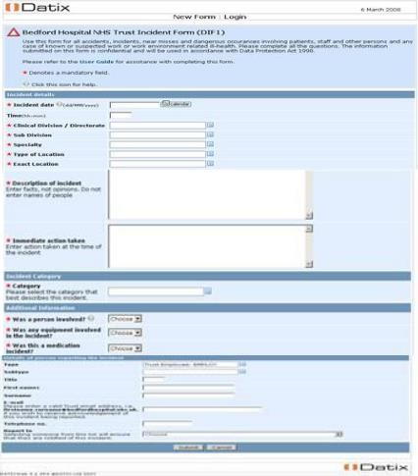

### Control of Substances Hazardous to Health (COSHH):

The COSHH Regulations 2002 (as amended) require all employers to make an assessment of the risks to health, which arise from exposure to hazardous substances in the work place. As part of this assessment employers must establish what measures are necessary to prevent or adequately control exposure to substances hazardous to health and what further precautions and emergency procedures may need to be taken to protect the health of employees. The Trust recognises that

the employer must safeguard not only himself and his employees but also anyone not in his employment who may be affected by his activities**.**

The COSHH Regulations requires the Trust to evaluate and control the risks to health of all their employees from exposure to substances hazardous to health at work.

The assessment should be performed by a competent person who may or may not be the departmental manager and documented on the Trust’s COSHH Assessment Form.

Employees should read the Trust COSHH policy, and COSHH Procedural document, available on the Trust Intranet

**COSHH Signage**:

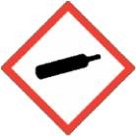New Symbol

*Contains* gas under pressure; may explode if heated.

Contains refrigerated gas; may cause cryogenic burns or injury.

COSHH Siqnaqe:

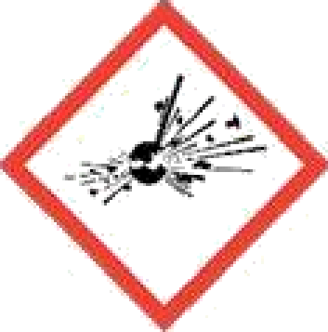Current Symbol Being Phased Out:

## Unstable explosive

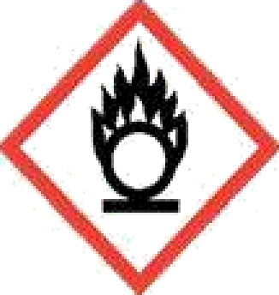Explosive; mass explosion hazard Explosive; severe projection hazard Explosive; fire, blast or projection hazard May mass explode in fire

Current Symbol bat Being Phased Out:

## May cause or intensify fire; oxidiser.

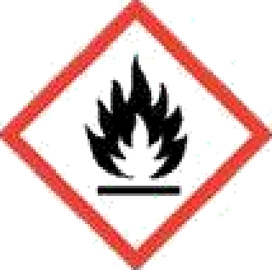May cause fire or explosion, strong oxidizer.

Current Symbol Being Phased Out:

Extremely flammable gas

## Flammable gas

Extremely flammable aerosol

Flammable aerosol

Highly flammable Liquid and vapour Flammable liquid and vapour

Flammable solid

COSHH Siqnaqe:



Current Symbols Being Phased Out:



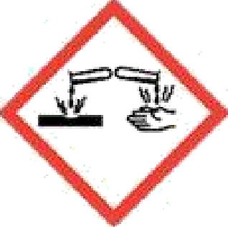May be corrosive to metals

Causes severe skin burns and eye damage

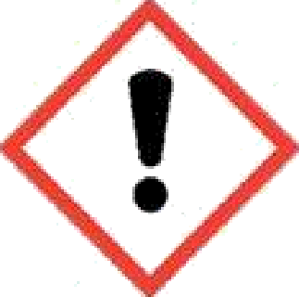Current Symbol Being Phased Out:

May cause respiratory irritation

May cause drowsiness or dizziness May cause an allergic reaction Causes serious eye irritation

Causes skin irritation Harmful if swallowed Harmful in contact with skin Harmful if inhaled

Harms public health and the environment by destroying ozone in the

upper atmosphere



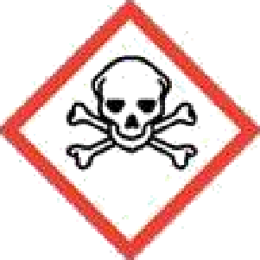Current symbols being out:

Fatal if swallowed

Fatal in contact with skin

Fatal if inhaled

Toxic if swallowed

Toxic in contact with skin

Toxic if inhaled

# COSHH Siqnaqe:

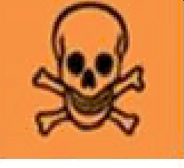

Current Symbols Being Phased Out:

May be fatal if swallowed and enters airways

Causes damage to organs

May cause damage to organs

May damage fertility or the unborn child

Suspected of damaging fertility or the unborn child

May cause cancer

Suspected of causing cancer May cause genetic defects

## Suspected of causing genetic defects

May cause allergy or asthma symptoms or breathing difficulties if inhaled

## Current symbols being phased out:

Very toxic to aquatic life with Iong lasting effects

Toxic to aquatic life with Iong lasting effects

### Work Place Stress:

**What is it?**

HSE defines stress as ‘An adverse reaction a person has to excessive pressure or other types of demands placed upon them’.

Workplace stress is different for everyone - what is stressful for one person may not be stressful for another. It can depend on your personality type and how you have learned to respond to pressure.

For further information read the Trust Prevention and Management of Workplace Stress – Trust Intranet.

### Physical and Verbal Abuse:

Abuse directed against NHS employees results from a complex combination pf personal and situational reasons such as fear, anxiety or frustration, drugs or alcohol and underlying clinical causes. It may be difficult to predict.

The Trust takes the issue of abusive behavior against staff seriously and sanctions such as verbal or written warnings.

Physical and Verbal Abuse:

In order to safeguard yourself employees are expected to:

* attend all relevant training sessions, such as conflict resolution
* be responsible for their own personal safety by risk assessing situations where they feel vulnerable and not to expose themselves and others to unnecessary danger.
* Inform your manager of any concerns
* Report all incidents using the incident reporting form (Datix)
* Comply with any lone working arrangements e.g. buddy system, use of lone working devices
* Call security on 5555 for Bedford and 01582 (49)7150 for Luton
* Panic Alarm on many of the reception areas/nursing stations

### Importance of reporting health and safety concerns:

It is important to report your health and safety concerns so the Trust can take action to mitigate the risk, by not reporting your health and safety concerns you may be putting other members of staff; visitors; contractors and patients at risk.

For further information read the Trust Health and safety Policy.

Reporting Process, and how the Trust uses the information:

The Trust requires that all incidents and accidents are reported via the incident / accident reporting procedure and are appropriately investigated.

The Trust will take an approach to learning from all such incidents in order to improve and assure its services, whether clinical or non-clinical. It recognises that such learning can only take place in a non-threatening environment.

The Trust will monitor all incidents on a regular basis and take preventative measures, as far as is reasonably practicable, to reduce the risk of similar incidents recurring.

Datix-Web is an electronic tool to report incidents that happen within the Trust. It is also to be used if employees are involved in incidents whilst on Trust business external to the site.

Datix-Web is accessed via the homepage on the Bedford Hospital NHS Trust Intranet.

There are two hyperlinks one under **Clinical Information** and the other within the **Online Reporting** section. The wording against these links is “DATIX - Report an Incident / Near Miss”. Either of these hyperlinks will take the user to the initial incident reporting

form which is also known as the DIF1 (DATIX Incident Form 1).

The red asterisks denote that these are mandatory fields and this information is required to be completed before the user can submit the incident.

For further information read the Trust Incident Reporting and Investigation Policy; or contact the Trust Datix administrator — Robert Buddle; Ext 5146 for Bedford or you can access the below for Luton site <datixweb-srv.xldh.nhs.uk/datix/live/index.php>

Health and Safety Quiz

### What reasons exist for managing health & safety? (Tick all that apply):

 Legal

 Economic Moral

 Customer Requirement

### A Hazard Is:

Something with the potential to cause harm something to fall over



 Something in the wrong place  A problem that has no solution

### Risk Is:

 Not knowing what is around the corner  Something you are not sure about

 A problem that is going to upset you

* Likelihood that harm from a hazard may be realised

### Reasons for investigating accidents (Tick all that apply):

 To learn from mistakes

 To show employees that you care

 To satisfy legal requirements under RIDDOR  For insurance purposes

**What ‘4Cs’ are critical in developing a positive safety culture?**

 Cool, Calm, Collected and Confident

 Competence, Control, Cooperation and Communication  Charismatic, Capable, Confident and Communication

 Charm, Charisma, Confidence and Control

Please sign on the next page when you have completed the questions.

*Have you……*

*Read all of the guidance? Yes/No*

*Checked that you have read*, *understood and are able to apply in your role? Yes/No*

Please read this guidance document and confirm your understanding by completing the return slip and returning this to your site specific training department for us to update your ESR records.

Alternatively, you can email your completed form to:

**Bedford:** [educationcentrebookings@bedfordhospital.nhs.uk](mailto:educationcentrebookings@bedfordhospital.nhs.uk)

**Luton:** [trainingbookings@ldh.nhs.uk](mailto:trainingbookings@ldh.nhs.uk)

|  |  |
| --- | --- |
| Full Name (please Print) |  |
| Department |  |
| Topic | **Health and Safety workbook** |
| Date Read |  |
| Signature |  |