Moving & Handling

Level 1 Theory

Workbook

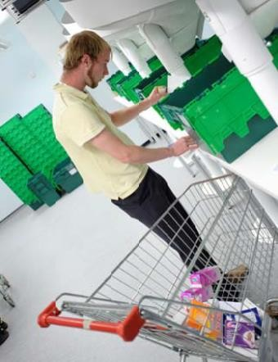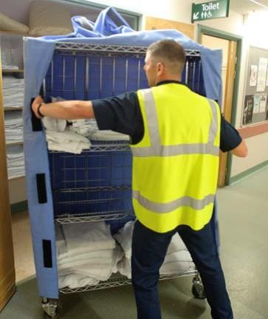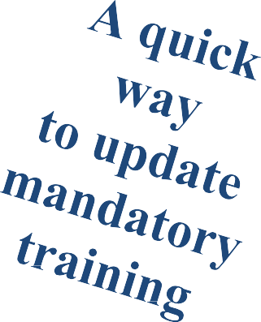

Moving & Handling Level 1 :

* Legal responsibilities
* Safer handling techniques
* TILE
* Musculoskeletal disorders
* Looking after your back

Version 2 – September 2023

## Learning Objectives

**Level 1: All staﬀ, including unpaid and voluntary staﬀ.**

The learner will:

* be able to recognise manual handling risk factors and how injuries can occur
* understand employers and employees responsibilities under relevant national Health & Safety legislation including most recent versions of the Manual Handling Operation Regulations
* understand their own responsibilities under local organisational policies for Moving and Handling
* know where additional advice and information can be sought relating to Moving and Handling issues
* be able to use an ergonomic approach to manual handling and other work tasks leading to improved working posture
* understand principles of good back care to promote general musculo-skeletal health
* understand the principles of safer handling
* know the factors to be included in undertaking an ‘on the spot’ risk assessment prior to undertaking a moving and handling activity
* understand how the organisation uses it risk management processes to inform safe systems of work
* be able to choose suitable risk control strategies, resources and support available to facilitate good practice following a risk assessment appropriate to the staﬀ member’s role.

Which training do you require?

## Section 1: Employers’ legal responsibilities

* + Provide a safe workplace and a safety policy
  + Avoid the risk (wherever possible).
  + Assess and document the risk, communicate significant findings.
  + Reduce the risk and review the risks.
  + Provide manual handling training in order to reduce the risk of injury to yourself, work colleagues and patients.
  + Monitor risk areas regularly.

## Section 2: Your duties as an employee

* + To take reasonable care for your own health and safety and that of others who may be aﬀected by their acts or omissions.
  + Co-operate with your employer, so far as reasonably practicable to enable the employer to comply with any statutory duty or requirement.
  + Report all accidents and near misses.
  + Report defects and hazards in your workplace including lighting, flooring and lack of equipment.
  + Attend and take note of any training.
  + Stop and assess all moving and handling activities.
  + Make full and proper use of safe systems of work, equipment and training provided.
  + Assist and cooperate in risk assessments.
  + Take responsibility for your own safety and report any medical conditions which may aﬀect your own manual handling capabilities.
  + Ensure that if you change location you attend and take note of any alterations of standard operating systems that may be diﬀerent in the new location.

## Section 3: Manual handling definition

Manual handling is defined an activity that includes any transporting or supporting of a load, including the lifting, putting down, pushing, pulling, carrying by hand or bodily force.

## Section 4: Safer handling technique

* + - Prepare the area – space, position of equipment and furniture.
    - Get into position.
    - Communicate eﬀectively and tell fellow workers what you are going to do.
    - Keep your feet apart for a wide, stable base.
    - Place your leading foot in the direction of travel.
    - Keep your spine in line within its natural curves.
    - Avoid twisting.
    - Have your knees and hips flexed rather than your back.
    - Have your elbows tucked in.
    - Pull in your abdominal muscles and keep tight.
    - Perform the move.
    - Evaluate the move. Ask the following. Did it go well? If not, why not? What would make it easier/safer? Do I need to inform my manager?
    - Do I need to complete an incident form?



**Good communication** is key when

lifting or moving items or objects as a team.

* **Ready**
* **Steady**
* **Push, Pull**

**Lift, Lower**

# Good Handling Technique for Lifting

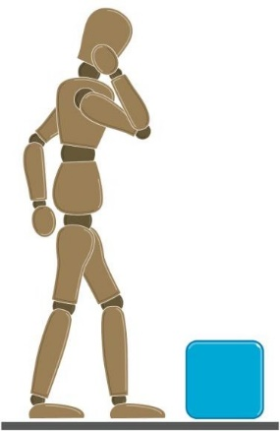 Think before lifting/handling.

* Plan the lift.
* Can handling aids be used?
* Where is the load going to be placed?
* Will help be needed with the load?
* Remove obstructions such as discarded wrapping materials.
* For a long lift, consider resting the load midway on a table or bench to change grip.
* DON’T lift or handle more than can be easily managed.

### Adopt a stable position

* + The feet should be apart with one leg slightly forward to maintain balance.
  + Be prepared to move feet during the lift to maintain their stability.
  + Avoid tight clothing or unsuitable footwear, which may make this difficult.

### 

### Start in a good posture

* At the start of the lift, slight bending of the back, hips and knees is preferable to fully flexing the back (stooping) or fully flexing the hips and knees (squatting). Maintain your own comfort.
* Raise the load, and then straighten the legs to avoid flexing the back further.
* Keep your head up when handling.

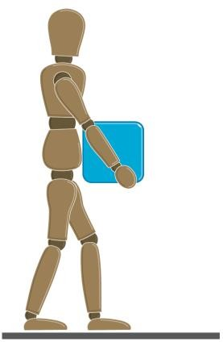

### Keep the load close to the waist

Keep the load close to the body for as long as possible while lifting. Keep the heaviest side of the load next to the body.

If a close approach to the load is not possible, try to slide it

towards the body before attempting to lift it.

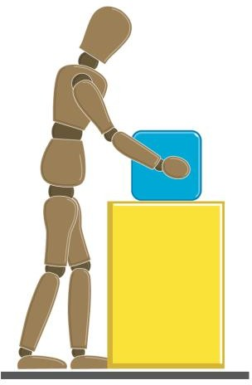

Avoid twisting the back or leaning sideways, keep shoulders

and hips facing the same direction.

Turn by moving the feet - this is better than twisting and lifting at the same time.

Move smoothly, jerky movements can make it harder to keep control and can increase the risk of injury.

**Put down, then adjust.** If precise positioning of the load is necessary, put it down first, then slide it into the desired position.

**Section 5: Risk Assessment (TILE)**

The potential adverse consequences of not carrying out an adequate risk assessment are **serious harm or injury** to patients and staﬀ and potentially raised levels of sickness from musculoskeletal injuries. There is also a potential of legal actions against the Trust with additional unnecessary costs to the Trust.

To minimise the risk of injury you should carry out dynamic risk assessment, known as T.I.L.E.

|  |  |
| --- | --- |
| Moving and Handling – Level 2 QCF, including patient handling - First ... | **Task**  Does it need to be done?  How often?  How much twisting, bending?  Any equipment aids to help?  Another healthcare professional to help? |
|  | **Individual**  Consider your capabilities and those that are assisting you – any injuries? your experience? Everyone up to date with moving & handling training?  Has consent been obtained?  Are you wearing suitable clothing and footwear?  Can you adopt a good posture? |
| nurse or doctor helping patient stick figure in hospital bed | **Load**  Weight  Weight distribution  Size  Safe working load of equipment  Patient specific – conscious, medication, physical and mental state |
|  | **Environment**  Is there enough space?  Is the lighting and flooring safe?  Attachments – drip stands, patient mobile phone and charger  Floor surfaces clear? Wet? Patient slippers.  Is the equipment visually safe? E.g. office chairs/wheelchairs/trolleys – all wheels working and (where applicable) brakes in working order. |

## Section 6: When using the equipment

## Check that it is the best tool for the job.

∙ Check the safety of the equipment.

∙ Check it is in good working order, maintained and in date of inspection

∙ Load the equipment/trolley appropriately.

∙ If height adjustable equipment is being used then adjust to a comfortable working height for you as an individual (between waist and shoulder height).

∙Keep arms close to the body.

∙Keep the spine in linewith in its natural curves.

### ∙ Avoid twisting and stooping.

∙Keep your head upright, (nose in line with toes). Use your leg muscles to move your body forward and push the equipment/trolley at the most suitable end.

# Good handling technique for pushing and pulling

The risk of injury may be reduced if lifting can be replaced by controlled pushing or pulling. For example, it may be possible to slide the load or roll it along

Here are some practical points to remember when loads are pushed or pulled.

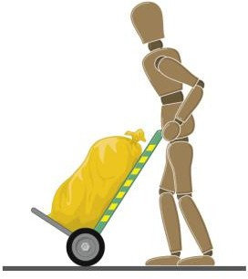**Handling devices.** Aids such as barrows and trolleys should have handle heights that are between the shoulder and waist. Devices should be well maintained with wheels that run smoothly. The law requires that equipment is maintained. When you buy new trolleys etc., make sure they are good quality with large diameter wheels made of suitable material and with castors, bearings etc. which will last with minimum maintenance.

**Force.** As a rough guide the amount of force that needs to be applied to move a load over a flat, level surface using a well-maintained handling aid is at least

2% of the load weight. The operator should try to push rather than pull when moving a load, provided they can see over it and control steering and stopping.

**Slopes.** Employees should get help from another worker whenever necessary, if they have to negotiate a slope or ramp, as pushing and pulling forces can be very high.

**Uneven surfaces.** Moving an object over soft or uneven surfaces requires higher forces.

**Stance and pace.** To make it easier to push or pull, employees should keep their feet well away from the load and go no faster than walking speed. This will stop them becoming too tired too quickly.

For both pulling and pushing, a secure footing should be ensured, and the hands should not be applied to the load much below waist height or above shoulder height. A further option, where other safety considerations allow, is to push with the handler’s back against the load, using the strong leg muscles to exert the force.

**Section 7: Your Back**

6

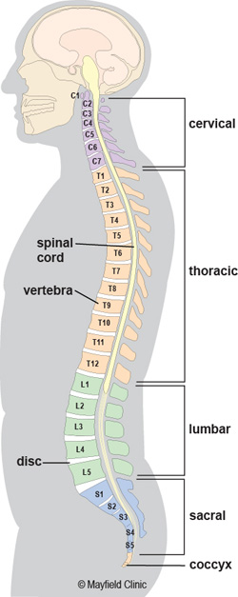

The spinal column provides support for the head and trunk, encloses and protects the spinal cord and is involved in most movements of the trunk and limbs.

The spine runs from the head to the pelvis and is made up of 33 individual bones called vertebrae.

It protects the spinal cord (nerve tissue) which is part of your nervous system. In-between the vertebrae are intervertebral disc which act as shock absorbers.

**Section 8: Musculoskeletal Disorders**

**Musculoskeletal Disorders are defined as:**

Injuries and disorders that may be aggravated by various hazards or risk factors at home and in the work place to the musculoskeletal system that includes:

Muscle, tendons, tendon sheaths, nerves, bursa, blood vessels, joints/spinal discs and ligaments.

Approximately half the manual handling injuries reported to the Health and Safety Executive each year involve injuries to the back/spine.

NOT JUST BACKS

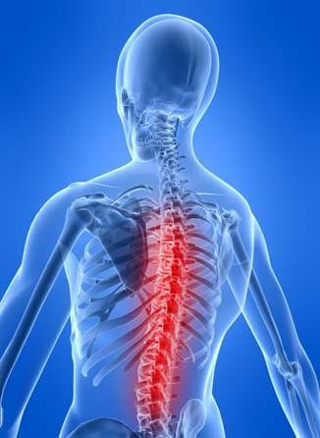

**Looking after your back**

Your back is a wonderful feat of engineering. However, you must look after it. A healthy back is needed to allow you to get the most out of life.

**Some causes of low back pain**

* Poor posture is often adopted when carrying out everyday tasks.
* The normal aging process.
* Lack of exercise.
* Twisting and bending forward
* Reaching and stretching
* Not following training

**Tips**

* Make sure the natural curve of your back is present when moving loads or working at low level.
* Take regular rests during handling tasks.
* Control your weight. Excess weight causes more strain on the back.
* Ensure good support for your back when in the car and in bed.
* Keep fit and flexible – take exercise/ stretch prior to strenuous activities.

**Section 8: Avoiding Injury**

**Avoid lifting heavy loads**

**Other factors to avoid injury**

**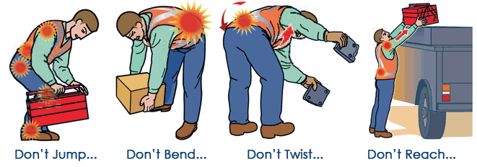******

## Section 9: Reporting

**Incidents reports** need to be completed for **all incidents including near misses**.

An electronic form known as the InPhase reporting system can be found in the ‘Do It Online’ section of the Intranet.

If you or a colleagues suﬀer a painful manual handling injury you must tell your colleagues, line manager and complete InPhase incident report.

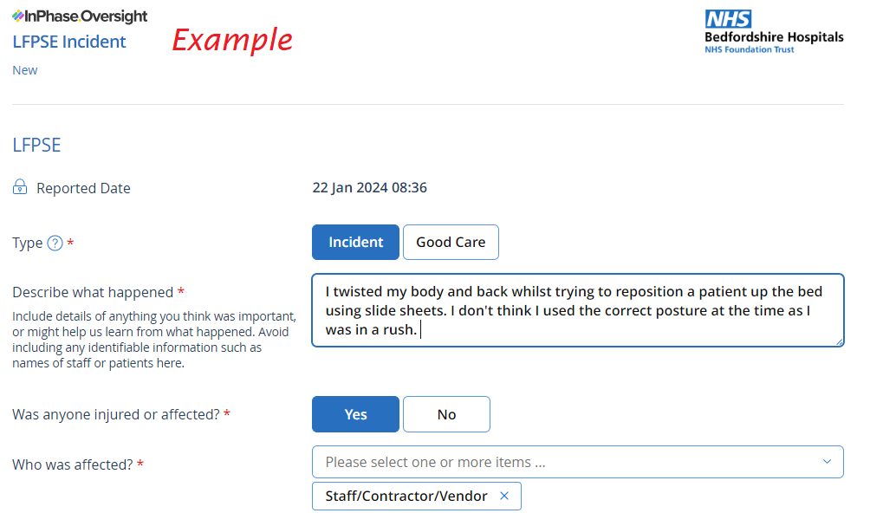

**Whistleblowing**

If you witness inappropriate handling techniques or something which concerns you, you should highlight this to your Line Manager or complete an InPhase form.

If you feel unable to do this for whatever reason, please refer to the “Freedom to Speak Up – Raising Concerns Policy” and/or speak with a FTSU Guardian which can also be found via the “Do It Online” section of the intranet.

**Section 10: Workstation Setup**

Display Screen Equipment (DSE) is a device or equipment that has an alphanumeric or graphic display screen.

The hospital has a display screen equipment policy which can be found on the Corporate Policies page of the Intranet.

Staff members who use display screen equipment need to complete their Workstation Assessment Checklist, which can be found on the Non-Clinical Forms page of the Intranet.

This checklist should be completed on commencing a job, every 2 years or when circumstance change.

Bel is some advice on how to adjust your workstation yourself, this is particularly useful if you have to share a desk (“hot desking”).

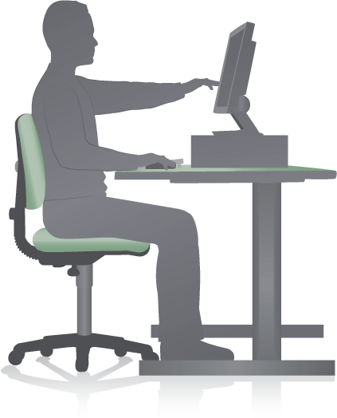

If you require further advice please contact the Moving and Handling Advisor, the Health and Safety Manager or Occupational Health

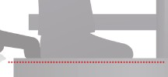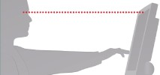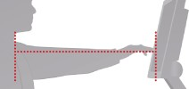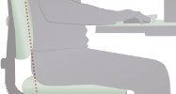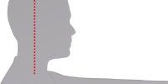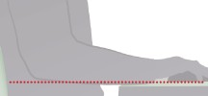How to adjust display screen equipment in your workstation

6. Feet flat on the floor

Use a footrest if your feet don’t reach the floor

5. The top of the screen should be at eye level

4. The screen should be

approximately an arm’s length away

3. Balanced head, not leaning forward

2. Balanced head, not leaning forward

1. Your forearms should be horizontal to the desk

**Other points to consider**

* Wrists not excessively bent (up, down or sideways)
* No excess pressure on underside of thighs and backs of knees
* Thighs parallel to the floor
* Space for postural change, no obstacles under desk
* Keep mouse in close to working area

**Checklist**

*Have you……*

*Read all the guidance? Yes / No*

*Checked that you have read*, *understood and are able to apply in your role? Yes / No*

Please read this guidance document and confirm your understanding by completing the return slip and returning this to your site specific Training & Development department for us to update your ESR record.

Alternatively, you can email your completed form to:

Bedford [EducationCentreBookings@bedfordhospital.nhs.uk](mailto:EducationCentreBookings@bedfordhospital.nhs.uk)

Luton [TrainingBookings@ldh.nhs.uk](mailto:TrainingBookings@ldh.nhs.uk)

|  |  |
| --- | --- |
| Full Name (please print) |  |
| Department |  |
| Topic | Moving & Handling Level 1 Theory |
| Date Read |  |
| Signature |  |