**Moving & Handling**

**Level 2 Theory**

**Workbook**

**For clinical based staff that do not require full practical training**

**If you are regularly moving patients, you MUST attend the practical session every 2 years.**

|  |
| --- |
|  |

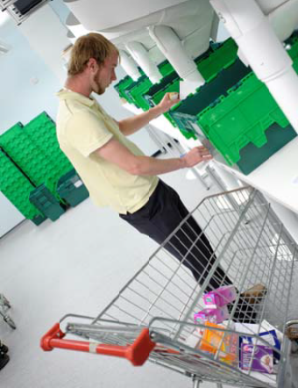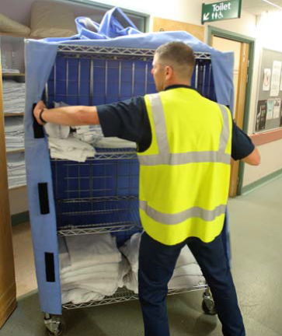

|  |
| --- |
|  |

Moving & Handling Level 2 Update:

* Legislation
* Sit to stand
* Use of wheelchairs
* Use of Slide Sheets
* Lateral transfers
* Transferring and transporting

patients

* Hoisting and Slings
* Bariatric equipment
* Safe working loads
* Emergency Handling Equipment

# **Introduction**

Bedfordshire Hospitals NHS Foundation Trust is committed to meeting its responsibilities to ensure safe practice in accordance with; The Health & Safety at Work Act 1974, The Manual Handling Operations Regulations 1992 amended 2002, Lifting Operations & Lifting Equipment Regulations 1998, Provision & Use of Work Equipment Regulations 1998 and the Human Rights Act 1998.

Further information can also be found on the Health and Safety Executive web page and the Moving and Handling Policy, which can be found on the Trust intranet. Other manual handling information may be obtained from Trade Unions and your own professional registered body.

The Manual Handling Regulations 1992 define manual handling as lifting, lowering, pushing, pulling, moving or carrying a load.

Level 2 workbook completion for: Clinical based staff that do not require full practical training element, but may be required at some stages to assist with some basic patient handling. To work within your own scope of practice.

Staff completing this workbook MUST NOT take the lead in any manual handling activity - this is an update only.

Level 2 practical training/update is for staff that regularly move patients by means of manual handling. This MUST be a practical face to face session. If you require this level 2 update - please book via the Education & Training Team

*Please read all the following sections*

**Lifting Operations and Lifting Equipment Regulations 1998 (LOLER)**

These Regulations (often abbreviated to LOLER) place duties on people and companies who own, operate or have control over lifting equipment. This includes all businesses and organisations whose employees use lifting equipment, whether owned by them or not. In most cases, lifting equipment is also work equipment so the Provision and Use of Work Equipment Regulations (PUWER) will also apply (including inspection and maintenance). All lifting operations involving lifting equipment must be properly planned by a competent person, appropriately supervised and carried out in a safe manner.

LOLER also requires that all equipment used for lifting be fit for purpose, appropriate for the task, suitably marked and, in many cases, subject to statutory periodic 'thorough examination'. Records must be kept of all thorough examinations and any defects found must be reported to both the person responsible for the equipment and the relevant enforcing authority.

In a Healthcare environment, LOLER regulations apply to any hoist transfers, including mobile hoists, ceiling track hoists, standing hoists and bathing hoists.

To ensure compliance with the regulations, the following processes are in place:

A trained person must complete daily inspection checklist for all lifting equipment.

Pre-use inspection of all lifting equipment, including slings, must be carried out.

The Clinical Engineering department manages Servicing and maintenance.

Service dates are clearly marked on each hoist.

Training is provided on Trust Induction and in Manual Handling update training.

Additional information around hoist transfers is provided in the hoist transfer section of this workbook.

**Sit to stand from bed to chair or chair to bed**

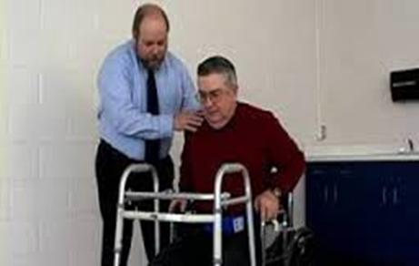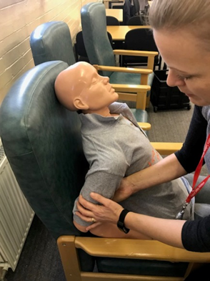

**Flat palm on shoulder/clavicle and lower back to support**

Benefits: Support for patients, more sense of how the patient is going to stand

**Should not go under patients arms**

Risks: Bruising to patient/ uncomfortable, shoulder dislocation, staff member injury

**Patient expectation**

Some patients may expect to be moved a certain way. If it is unsafe, give full explanation to the patient.

**Remember**, if they are struggling to stand - think- reassess- new equipment to aid may be required.



**Consider** asking the patient which side of bed that they get out of at home- this may make it easier for them to get out of bed as is familiar to them.

**Use of wheelchairs**

* Assess/ask how much help (if any) the patient will require getting into and out of the chair. In-patients should all have a Manual Handling risk assessment form, which indicates how they should be moved and what they are capable of doing.
* Make sure the wheelchair is in good working condition i.e. brakes work, tyres have sufficient air, foot rests swing properly and can be fixed in place, and that there are 2 handles on the back of the chair. Make sure the wheelchair is correctly opened and the seat is in the correct position. Ensure it is clean.
* Make an assessment of the weight of the patient, especially in relation to your own health and strength, (individual capability). If your assessment determines that to move this patient is outside your own individual capability, do not attempt to move the patient, ask for assistance.
* Ensure patient communication: to await instructions, not to get out of the chair before advised to and not to stand on the footrest.
* Ensure that the chair is situated next to/as close as possible to the patient, that both brakes are on and the footrests are pushed out of the way.
* Hold the chair steady at the back, whilst the patient sits down. The assessment at stage 1 will indicate whether you need assistance at this point.
* Bending your knees as opposed to your back bend down and secure the footrests in place with the patient’s feet resting against the plastic heel stops.
* Make sure the patient is comfortable and their hands and any clothing/rugs etc. are resting securely on the inside of the wheelchair
* Take the brakes off!
* When pushing or turning the chair make sure that you are as close to the chair as possible. Do not push at arm’s length! Even if you are going slightly uphill.
* Use lifts instead of slopes wherever possible.
* For doors that open towards you, stop and put on the brakes. Open and secure the door – most have a magnetic catch and then push the wheel chair through, having first assessed the area you are walking into for obstructions, wet floors etc. Release doors after you especially if they are fire or ward doors.
* Stop at any time if you feel that the patient is unstable in the chair or pushing becomes too strenuous!
* Never tip the wheel chair forwards or backwards. If you are going over kerbs or small bumps in the door frame turn the wheelchair around and pull over backwards without tipping the chair, again make an assessment as at stage 3.
* Aim for a steady, smooth move.
* When you arrive at the destination do all the above in reverse!
* Any incident/near miss, unavailability of wheelchairs must be reported via the Trust reporting system.
* Should the wheelchair require basic repairs i.e. inflation of tyres, please contact and report to the maintenance dept. When pushing a wheelchair keep your elbows relaxed and tucked in while pushing close to the load.

**Lateral transfers**

**Flexible Roll Board (SWL 150kg)**

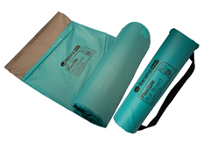Minimum of 2+ members of staff

The procedure (e.g bed to trolley)

* Remove the Flexible Roll Board from its bag
* Untuck the bed sheet all the way round the bed
* Roll the patient onto their side using the bed sheet
* Place the Flexible Roll Board under the patient
* Roll the patient back onto their back
* Bring the trolley to the side of the bed
* Using the bed sheet both members of staff can transfer the patient across to the trolley by pulling at each end of the bed sheet
* Someone should always be present at foot end to elevate feet to avoid any shearing from bed sheet. Consider whether someone requires a member of staff at head end.
* The transfer can be completed in one movement.
* This can be wiped down with green Clinell wipes and rolled back into its bag.

**Transfer Board**

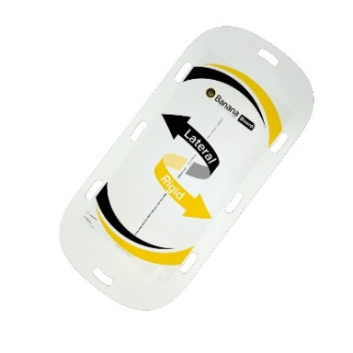What equipment is required?

* 3 to 4 members of staff – must assess
* 2 single sliding sheets or 1 tubular slide sheet
* 1 transfer board

The procedure

* Place slide sheet(s) beneath patient
* Remove head board and foot board if possible
* 1 staff member at head end and 1 staff member at foot end
* Roll patient onto their side and insert transfer board to bridge the gap
* 2 staff members placed on side of patient
* Sliding sheet will be used to slide patient arm’s length towards other bed
* 2 part process - more comfortable for the patient
* 2 staff members then move to receiving new bed- and pull the sliding sheet the rest of the way to the receiving bed
* Always use: Ready, Steady, Slide

Patients should not be moved across onto the new bed using a bed sheet. Using the above technique removes the need for staff to climb onto the beds- this is a risk for staff injury and also an infection control issue.

**Transferring & Transporting**

Staff/porters who are transferring patients around the hospital on beds 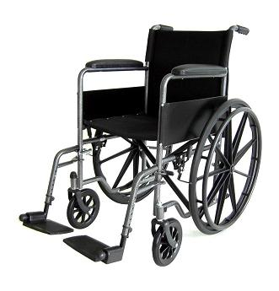should consider:

* Does the patient need to be on the bed, can they be transferred by wheelchair?
* When transferring the patient on the bed, the bed should be raised at waist height level for ease of movement.

Two members of staff should handle the pushing and pulling of the bed and it should be moved with ease but not fast that it poses a risk of injury to others.

Ensure the footbrake positions are in correct position for travelling along corridors, and steering around corners.

Assessment should be made when moving a bariatric bed and patient with regards to how many staff are required to push the bed (more than 2 members of staff). Consider use of bed pusher.

Corridors and access areas should be free of clutter to ensure smooth transportation of beds or trolleys, to avoid accident or injury, to patient, staff and visitors.

**Sliding sheets**

Sliding sheets are an integral part of Moving and Handling. They allow the friction-free movement of a patient on almost any surface.

* Always check the sliding sheets prior to use
* They remain with the patient throughout their stay
* Discard if they look worn, soiled or ripped

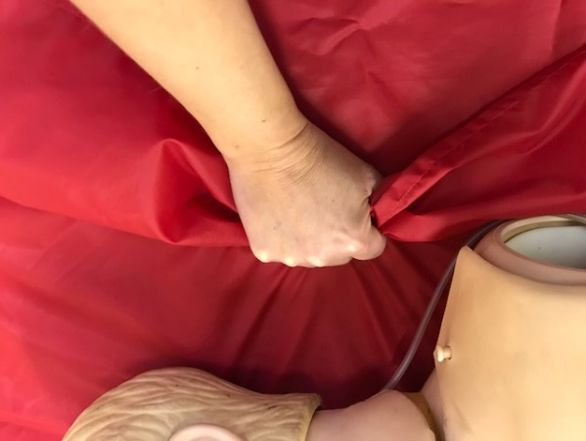Technique of using the sliding sheets:

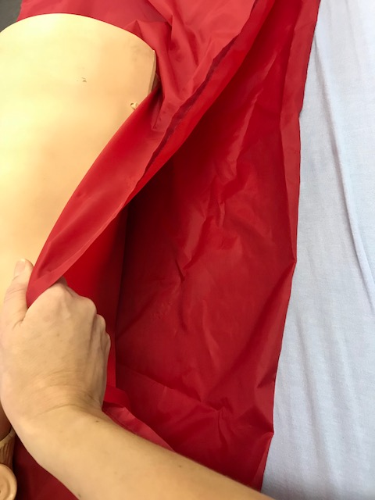



The left image shows the slide sheet is being lifted - rather than sliding

Keep your knuckles on the bed, and close to the patient to reduce the risk of lifting the sliding sheet. Keep the top sliding sheet taut, this will assist with effective sliding.

Use the command: Ready, steady, slide.

Always assess - if the patient is larger- more staff will be required to slide.

There are several ways of inserting the sliding sheets – please attend the practical session if you require further training.

**Bariatric equipment**

Refer to Clinical Policy Safe Handling of Plus Size/Bariatric Patients

DEFINITION:

A person with a known or suspected weight of over 25 stone.

A person who has complex manual handling problems due to size and/or shape.

A person who does not fit into standard equipment.

* Always check equipment for weight (safe working load).
* Obesity is defined as a BMI above 30.
* Patients with a BMI over 40 are classed as Bariatric.
* Bedford site has one bariatric hoist - bleep porters if needed.
* Bariatric rental folder for beds and other equipment available in all areas. A digital form is on the intranet.

Bariatric Slings and Sliding Sheets

* Daytime hours:  Bariatric slings and sliding sheets are stored in the bariatric cupboard in the emergency linen room and can be obtained through porters; they will also require which ward the patient is on.
* Out of hours: Bariatric sliding sheets and XL and XXL slings can be located in the emergency linen cupboard (Britannia road entrance, opposite Primrose) - access to this room is via porters or out of hours site managers.

**Safe working loads**

Safe working loads – consider **L.O.L.E.R** (Lifting Operations Lifting Equipment Regulations)

**Hoist**

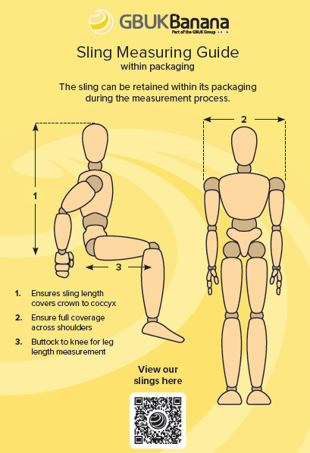All patients that require hoisting need to be measured appropriately for the correct fitting sling, using the length of the packing as your measurement. There is a risk of patients falling from a sling too large, or pressure area/comfort problems from a sling too small.

Sizes available are Small, Medium, Large, X Large - SWL 275kg

**XXL** – 400kg (Contact Moving & Handling Lead if you think this is required as a risk assessment is required – Jan Bordiak 07974098244)

Always hoist with at least two staff members.

**Measure from crown to coccyx whilst still in the wipeable packaging – the length of the package indicates the length of the sling.**

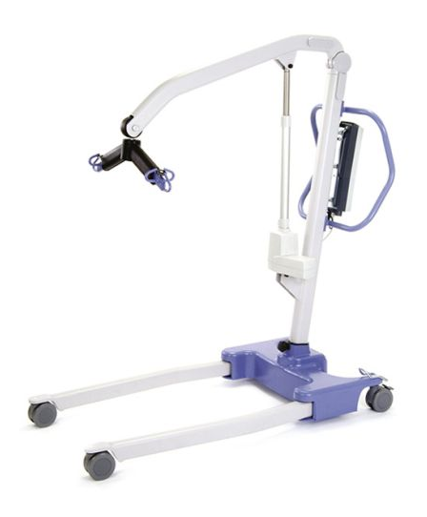

Hoist checks prior to use:

* Is it clean?
* Does it have adequate battery life?
* Is LOLER (maintenance) in date?
* Check legs/arm works with handset
* Visual check for broken parts

**Breaks should ONLY be applied when it is parked and not in use.**

**Standing hoists/aids:**

**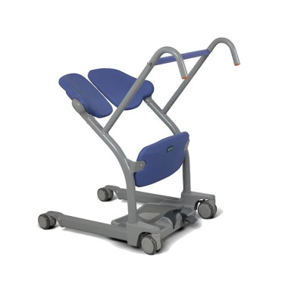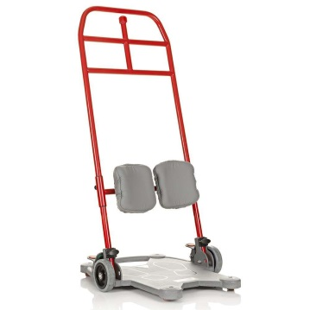***Only use the hoist or standing aid if you have been given practical training to use it. Always ensure someone experienced leads and guides*.

**Stedy – 120kg**

**Sara Stedy – 182kg**

**Height 4’11-6’6**

**ReTurn 7500i – 150kg**

**ReTurn 7600 – 205kg**

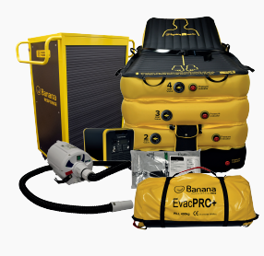**FloJac**

Used for recovery of fallen patient from floor level onto a bed or trolley. If dealing with serious injuries (NOF, spinal etc.) a Ferno scoop or spinal board should be used prior the use of the FloJac. Additional training for the safer handling of the fallen patient can be received during Level 2 Moving & Handling updates and via the Falls Prevention Team.

Some kits also contain a battery power back and EvacPro+ for emergency evacuation.

Practical training is required for the use of this equipment therefore please book onto a session.

**Directions**

* Take the FloJac out of the trolley and sleeve and roll out onto the floor ensuring that the patients head is at the head end of the device (indicated by the head icon)
* Ensure ALL five-inlet valves are closed on the device. If these are not closed, twist the round valve handle to the left slightly (anti-clockwise).
* 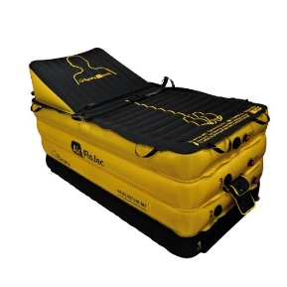The inflation pump should be plugged into a socket or supplied power pack within easy reach of device and should not be a trip hazard
* Transfer the patient onto the FloJac by using either slide sheets or Air Transfer Mattress (SWL 453kg), ensuring they are centred on the device
* Secure the patient on the FloJac by loosely connecting the safety straps across the patients body. DO NOT tighten the straps.
* Starting with Layer 1, press on/off button on the compressor and inflate this layer; this will inflate within seconds. The inlet valve will open once the hose nozzle (with adapter) is pushed onto the inlet valve
* Repeat this process for layers 2, 3 and 4 or until the FloJac reaches the desired height.
* There is also a 5th chamber which can be inflated allowing the patient to sit up (pregnancy or respiratory reasons)

|  |  |  |  |
| --- | --- | --- | --- |
| cid:8505913350570644017061347 | cid:8664315692654111137407460 | cid:8268018034737578257753573 | cid:6326418034737578257753573 |

* The patient trolley or bed can now be brought alongside the FloJac to enable the patient to be laterally transferred using methods mentioned above.

Demonstration videos can be found at [here](https://www.gbukgroup.com/brands/gbuk-banana/elevation-devices/flojac/banana-flojac/)

https://www.gbukgroup.com/brands/gbuk-banana/elevation-devices/flojac/banana-flojac/

Mobility status posters that are situated at the back of patient bed space to easily identify mobility requirements.

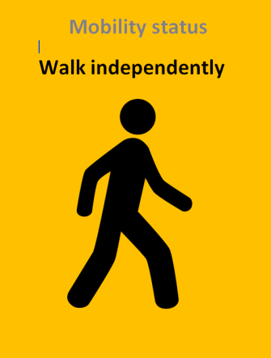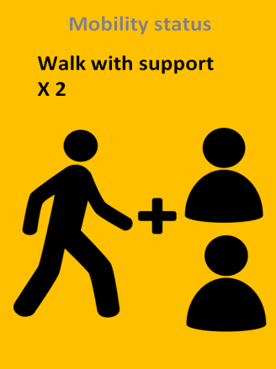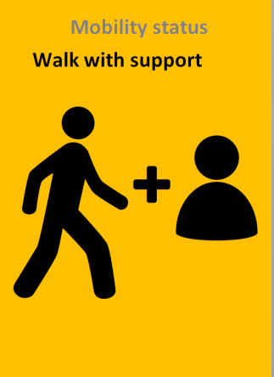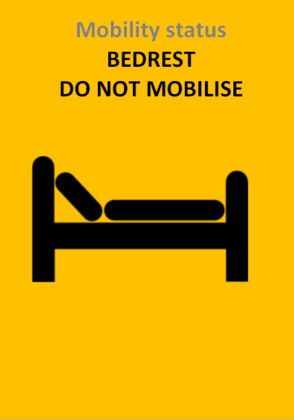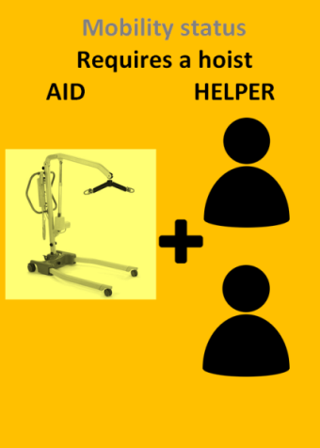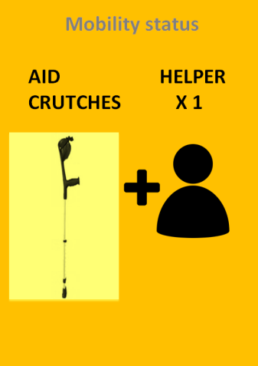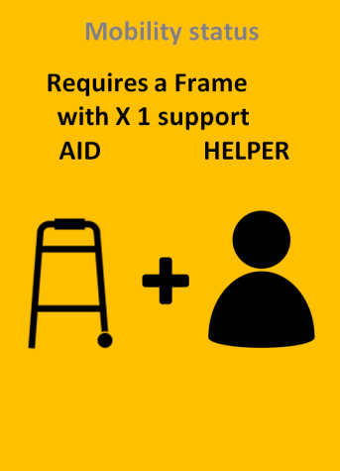

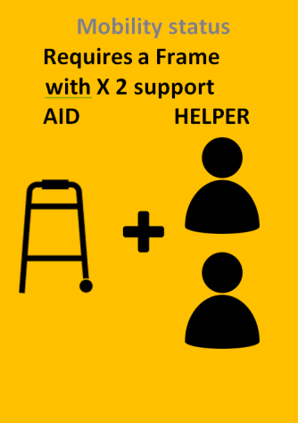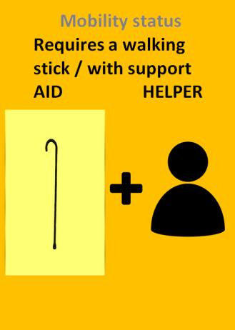



Assess patient regularly and change posters as necessary

**Moving and Handling Champions**

Moving & Handling Champions are a great way to offer support within the clinical environment, they are aware of their areas needs and issues, and continue to provide training into the working environment.

Having the champions within the clinical area highlights best practice and motivates others to do the same.

Benefits of having and being a champion following training within the ward area:

* Role model within area
* Improving practice within area
* Highlight good/ bad practice
* Expert within your own area
* Filter updates and information to staff within own area
* Enhancing own specialist knowledge
* Assisting with audits
* Regular team updates/training

Training is over a 2 day course provided by Moving and Handling Advisor.

Moving and Handling Champions can carry out specific moving and handling training within their own area of expertise.

For more information or to book onto the course please contact:

[Jan.Bordiak@bedsft.nhs.uk](mailto:Jan.Bordiak@bedsft.nhs.uk)

**Checklist**

*Have you……*

*Read all of the guidance? 🗸*

*Checked that you have read*, *understood and are able to apply in your role? 🗸*

Please complete the following details and return this page to Training and Development and your record can be updated. If you feel that you would like further practical skills training, please identify clearly in the statement below. I agree I have read the above level 2 refresher and am aware of the required standard to safely practice the range of procedures within my scope of practice and role. I understand the process of risk assessment and will seek support and discuss workplace issues as appropriate.

|  |  |
| --- | --- |
| Full Name  (please print) |  |
| Department / Ward |  |
| Topic | Moving & Handling Level 2 Theory |
| Date read |  |
| Signature |  |

Please email your completed form to:

[EducationCentreBookings@bedfordhospital.nhs.uk](mailto:EducationCentreBookings@bedfordhospital.nhs.uk)

Or more information please refer to:

<https://bhintranet.bedsft.nhs.uk/departments/clinical/manual-handling/>

To book onto Moving & Handling Level 2 Practical Training

<https://www.bedsft-training.co.uk/>